# Section 2: Introduction to AWS Cloud Computing

## Section 2, Lecture 6 AWS Platform

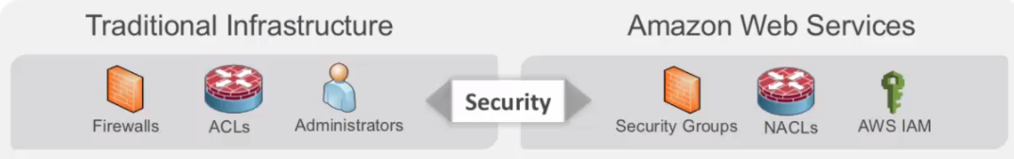

* Security Layer
* ACLs: Access Control Lists
* NACL: Network Access Control Lists
* AWS IAM:
  + AWS Identity Access Management
  + Control user-based access to the platform
  + Control what those users can do within the AWS environment

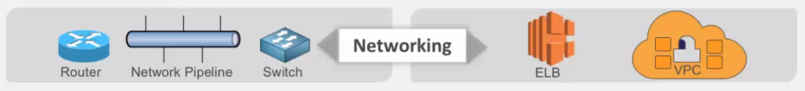

* Networking Layer
* VPC
  + A Virtual Private Cloud
  + We create it and assign IP addresses
  + We also create subnets within those environments
  + Within the VPC, we launch our application services
* ELB
  + Elastic Load Balancers

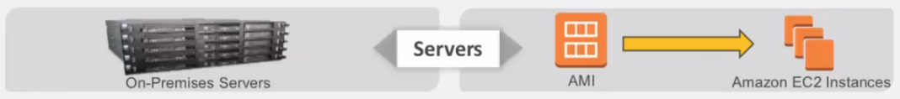

* Server Layer
* AMI
  + Amazon Machine Image
  + Like an image of an operating system that we can use to create an EC2 instance
  + A virtual server running in the cloud

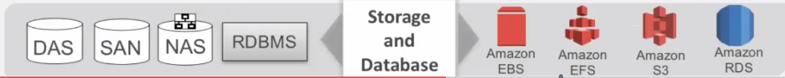

* Storage and Databases
  + Amazon EBS: Elastic Block Store
  + Amazon EFS: Elastic File Store
  + Amazon S3: Simple Storage Service
  + Amazon RDS: Relational Database Service
* Choose the right one based on cost and performance

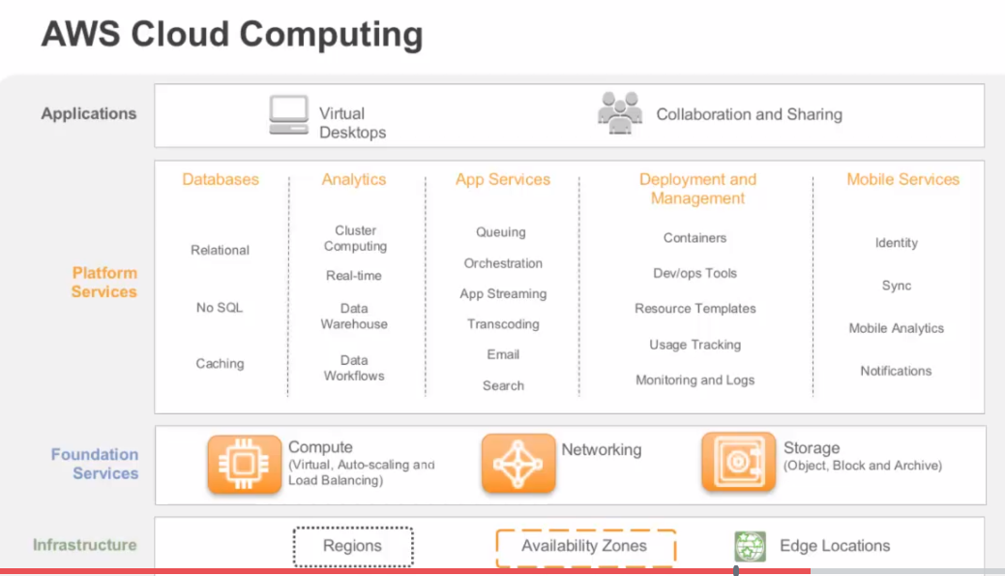

How we break down AWS Cloud Computing into the 3 critical layers, which is:

* Foundation Services
* Platform Services
* Infrastructure

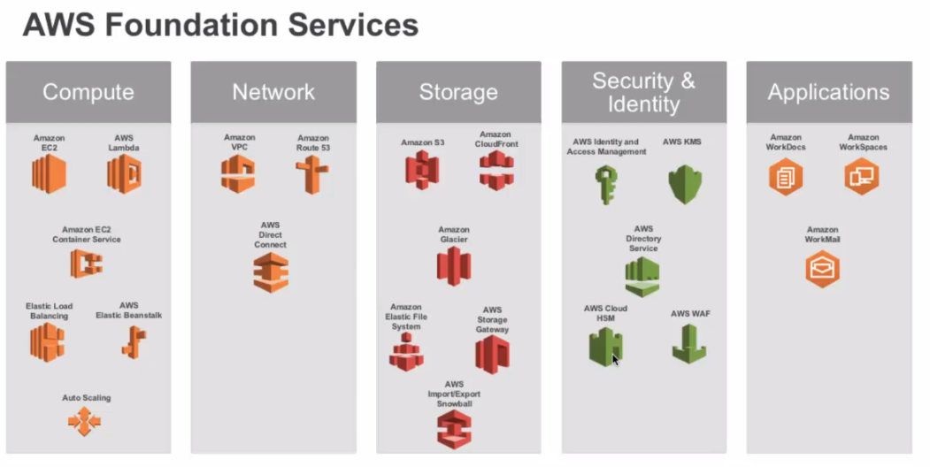

5 primary categories

* Compute
* Network
* Storage
* Security & Identity
* Applications

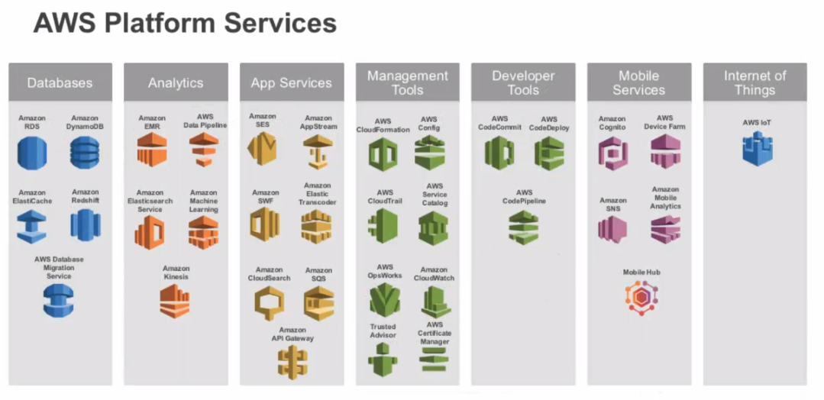

## Section 2, Lecture 7 AWS Global Infrastructure

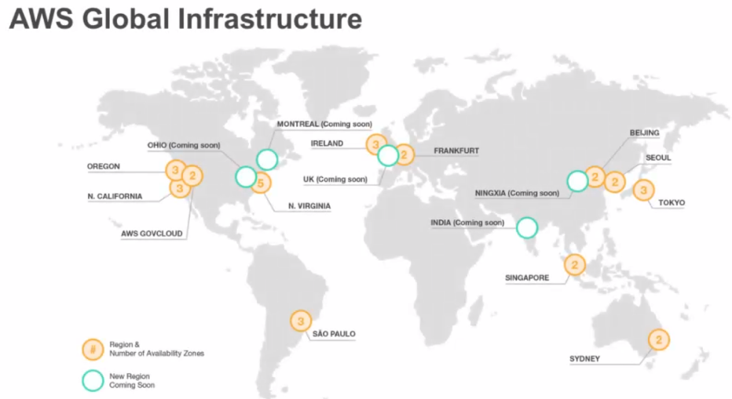

* 4 decisions you have to make before making a correct choice of a region
* Latency
* Regulatory compliance control
* Cost
* Service availability

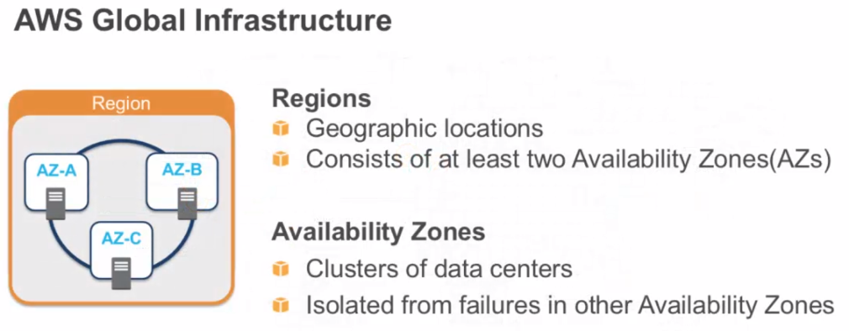

* AWS Regions are geographic locations that contain multiple availability zones
* Availability zones consist of multiple data centers clustered in a region
* Each availability zone is engineered to be isolated from failures in other availability zones

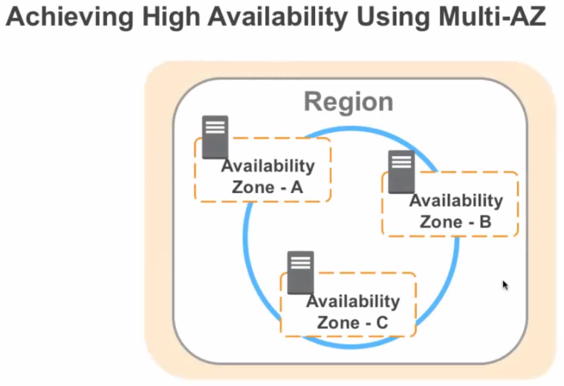

* It’s important that you understand how we build each region with multiple availability zones, so you can architect highly available and fore-tolerant application workloads, when building in an AWS environment.
* You have to provision your computing resources across multiple availability zones.
* If you have multiple instances, you can run them across more than one AZ (Availability Zone), and get added redundancy.
* If a single AZ has a problem, all assets in your second AZ will be unaffected.

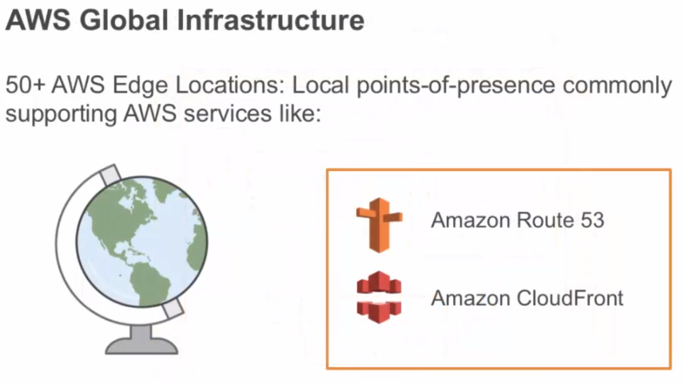

* Another part of the AWS global infrastructure, are the 50+ AWS Edge Locations that we maintain.
* These are local points-of-presence, commonly supporting AWS services like Amazon Route 53 (Amazon’s DNS service) and Amazon CloudFront (Amazon’s content distribution network).
* Edge locations help reduce latency, and improves performance for end users.
* An AWS Edge location, hosts a robust content delivery network that can be used to deliver websites (dynamic and static), and streamlining content.
* Requests for content are automatically routed to the nearest Edge location, so content is delivered with the best possible performance.

# Section 3: AWS Foundational Services

## Section 3, Lecture 9 Amazon Compute Services

### Amazon Elastic Compute Cloud (EC2)

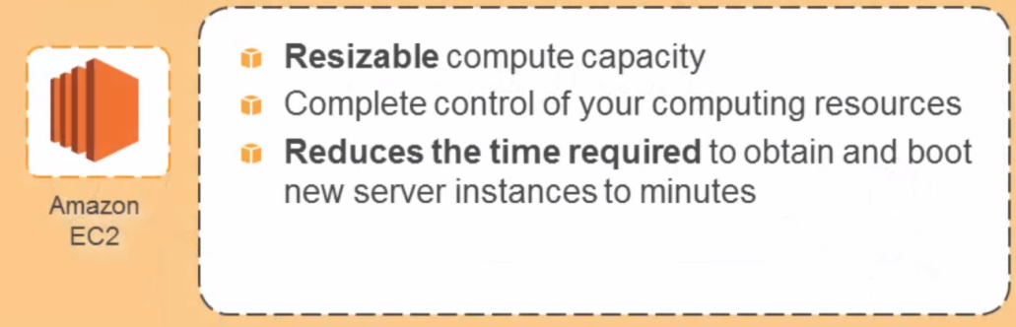

* Amazon’s EC2 instance is a virtualized server that runs in the AWS data centers
* It’s designed to make webscale computing easy for developers and IT pros
* EC2’s simple web interface allows you to obtain and configure capacity with minimal friction
* It provides you with complete control of your computing resources
* It allows you to run on the Amazon’s proven computing environment.
* Amazon EC2 reduces the time required to obtain and boot new server instances.
* It allows you to quickly scale computing capacity, as your computing requirements change.

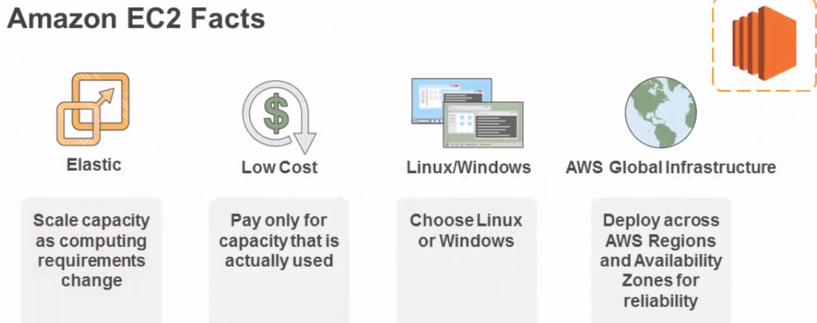

* EC2 presents a true virtual computing environment, allowing you to use the webservice interfaces to launch instances with a variety of operating systems, load them with your custom application environment, manage your network access permissions, and run your image as many, or as few systems that you may need.
* You have the ability to programmatically scale your computing capacity, as your requirements change.
* You pay only for the capacity that you actually use, and can either choose Linux or the Windows OS.
* You can leverage the AWS global infrastructure to deploy across regions and availability zones for reliability.

Installation process

* 1. Think about the region you want to launch your instances in.
* 2. Choose an Amazon machine image or AMI.
  + AMIs are the building blocks of an EC2 instance
  + They are the template of a computer’s volumes
  + AMIs can have a public, or a private access
  + You can also create gold master images of you Amazon EC2 infrastructure, which allows you to decrease your boot times.
* 3. Select an instance type
  + An instance type is a preconfigured hardware specification of your instances.
  + Different from virtualized machines where you specify the amount of gigs of RAM and storage space.
* 4. Configure networking
  + Firewalls in the form of a security group, provision block storage volumes, and use a keypad to log into your EC2 instances.

## Section 3, Lecture 10 AMIs and Instances

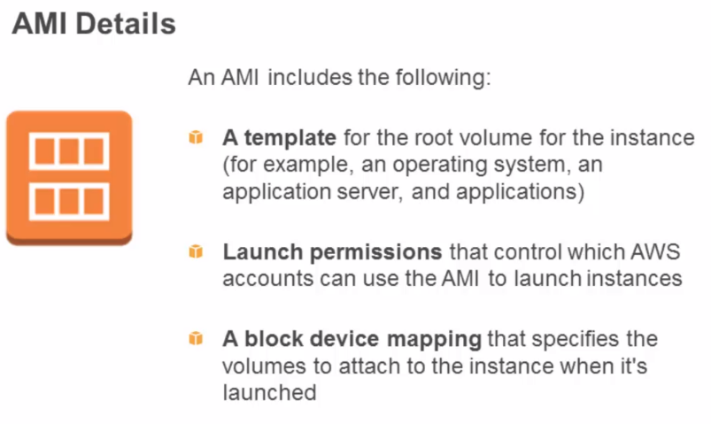

* AMIs are the building blocks of EC2 instances.
* An AMI is a template that contains a software configuration, such as an operating system, application server, and applications.
* Use an AMI to launch an instance, which is a copy of the AMI, running as a virtual server on a host computer in the AWS data center.
* You can launch as many instances as you want from an AMI.
* You can create your own AMI, by customizing the instance that you launch from a public AMI, and then saving the configuration as a custom AMI for your own use.
* You can also buy, share, as well as sell AMIs
* AMI also includes a **block device map** that specifies the volumes to attach to an instance when it is launched.

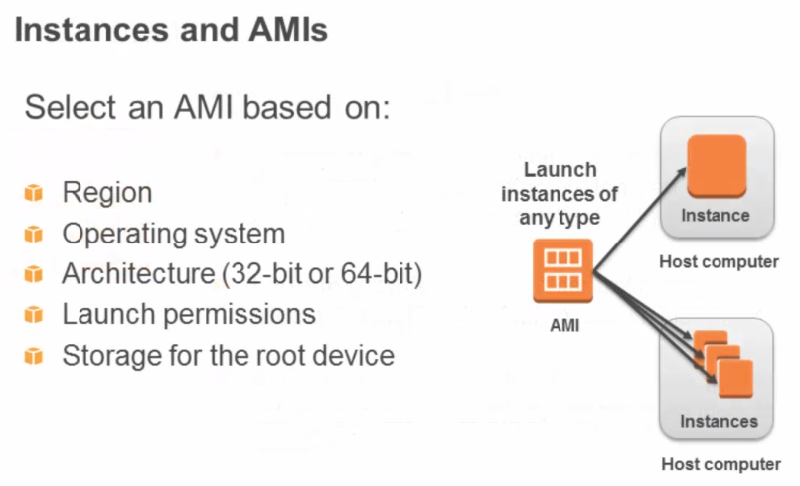

* Launch permissions determines the availability of an AMI
  + Can be public: The owner grants the launch permissions to all AWS accounts
  + Explicit: The owner grants the launch permissions to a specific AWS account
  + Implicit: The owner has implicit launch permissions for the AMI

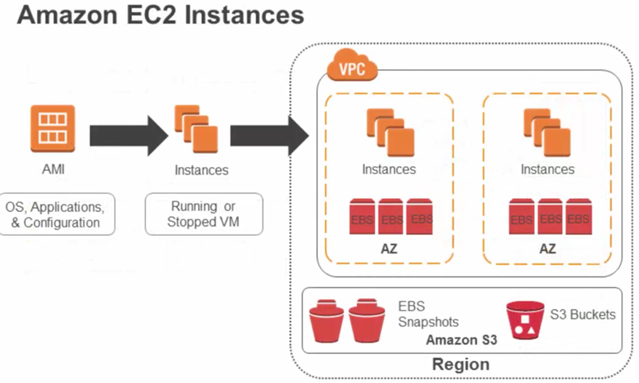

* You can launch multiple instances of different types, from a single AMI, when launching an EC2 instance.
* An instance type determines the hardware of the host computer, used for your instance.
* Each instance type offers different compute and memory capabilities.
* Select an instance type based on the amount of memory and computing power that you need for your application or software, that you plan to run on the instance.
* An instance keeps running until stopped or terminated, or until it fails.
* Instances are deployed in the Amazon’s EC2 public cloud, and the Amazon virtual private cloud in an availability zone within a region.
* You can configure security and network access on your Amazon EC2 instance.
* Customers can then deploy to multiple availability zones within a region.
* You choose which instance types you want and then start, terminate, monitor as many instances of your AMI that you need, using the webservice APIs, or variety of management tools provided.
* EC2 instance can leverage elastic blocks (to volumes ?) in each availability zone.
* Determine whether you want to run in multiple locations, utilize static IP endpoints, or attach persistence block (toes?) to your instances.
* Amazon EBS volumes can be saved in snapshots
* Amazon S3 buckets can be used to store data objects that are required by your EC2 instances

## Section 3, Lecture 11 Instance Store and EBS

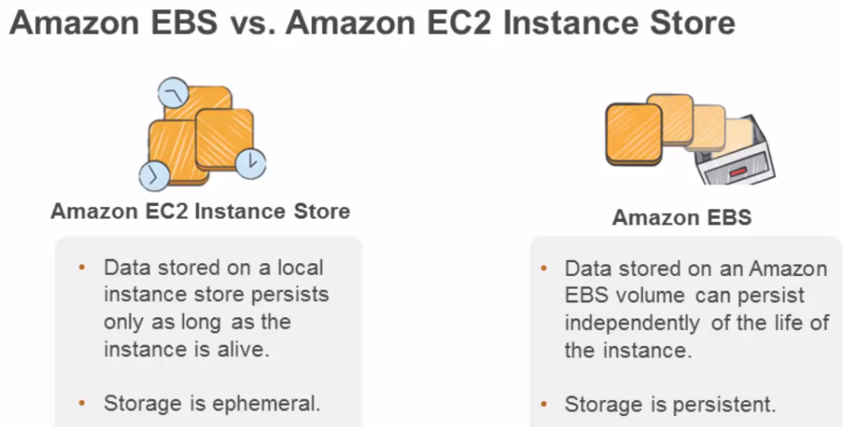

* Use the local instance store volumes, which is the EC2 instance store, or the EC2 ephemeral volumes, only for storing temporal data.
* Why? When you stop and start an EC2 instance, the underlying host is changed. The EC2 instance store volumes are presented to the EC2 instance, via the underlying host. When you stop and start, the data is lost.
* For data requiring a higher level of durability, use the Amazon EBS volumes, or back up the data to Amazon history.
* If you use Amazon EBS volume as your root partition, ensure that you set the “Delete on Termination” flag to no, if you want your Amazon EBS volume to persist outside the life of the EC2 instance.

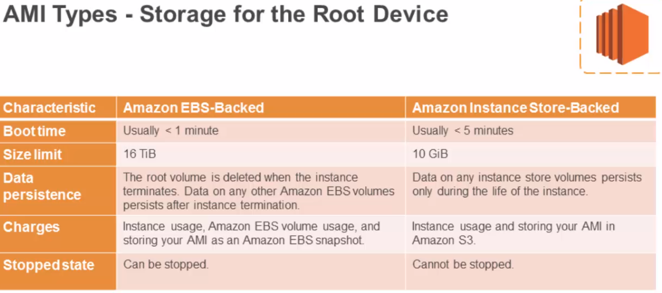

* AMIs are either EBS-Backed or backed by the instance store volumes.

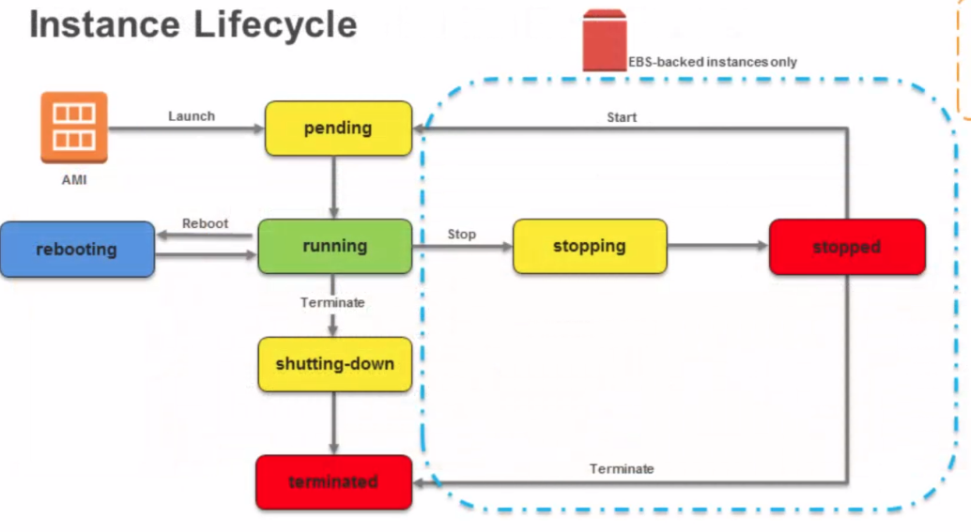

This is the lifecycle of an instance launched from an AMI.

## Section 3, Lecture 12 AWS Marketplace

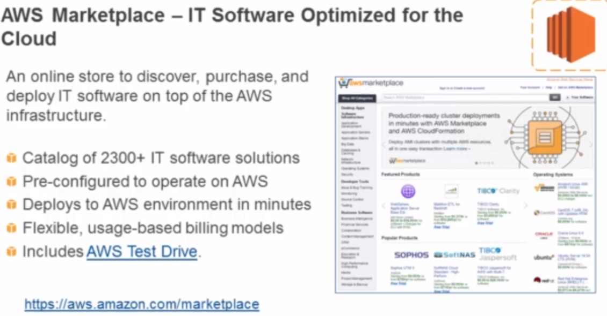

aws.amazon.com/marketplace

## Section 3, Lecture 13 Choosing the Right Amazon EC2 Instance

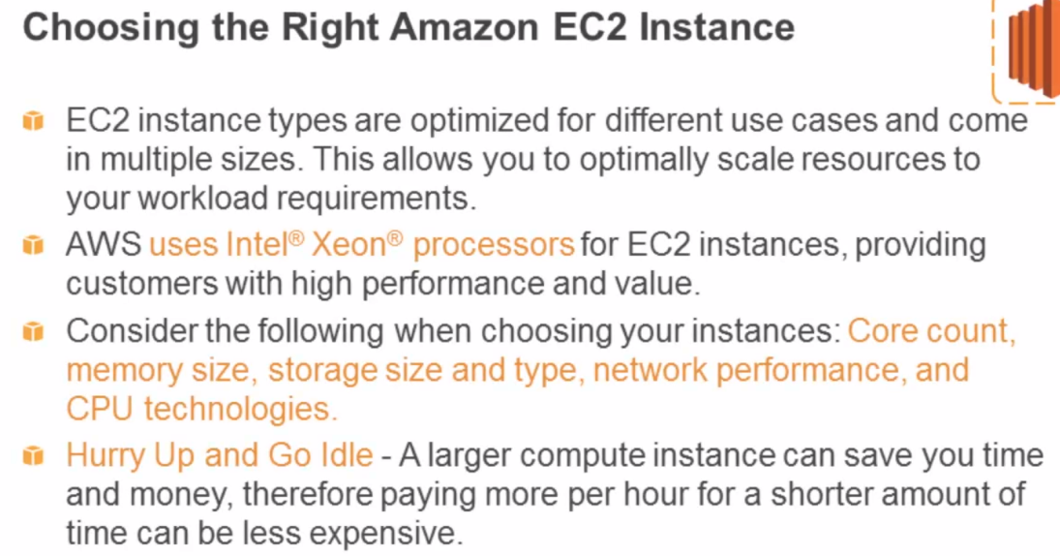

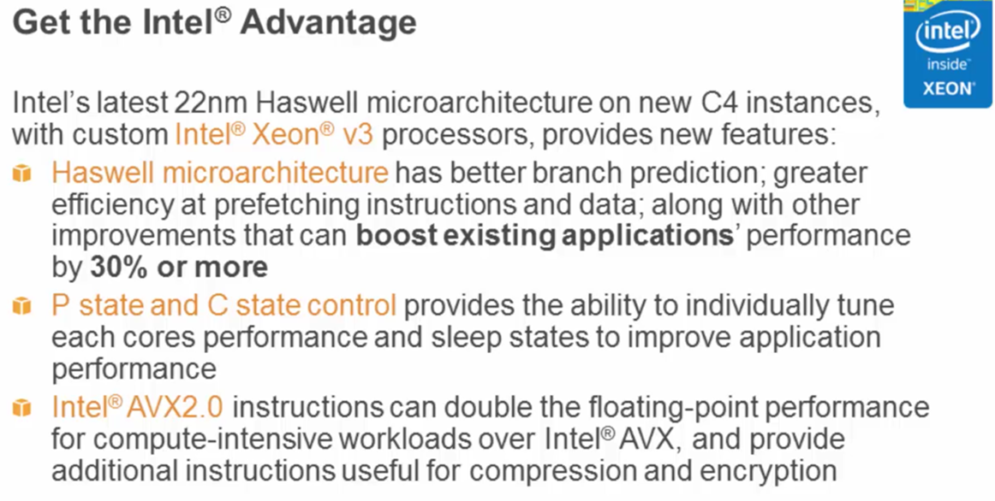

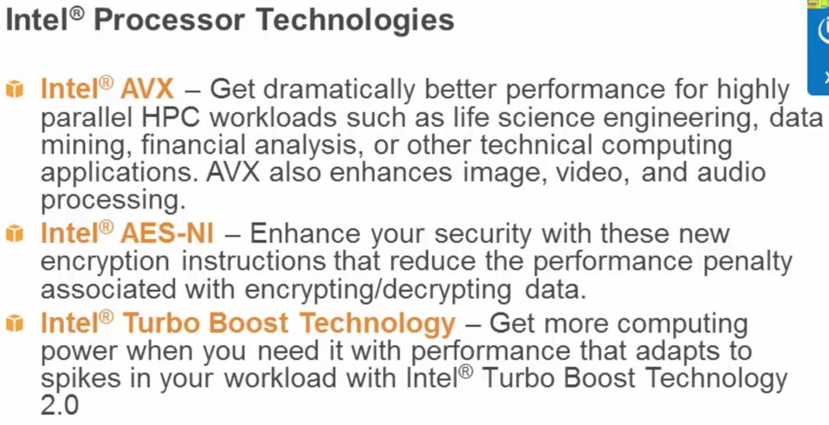

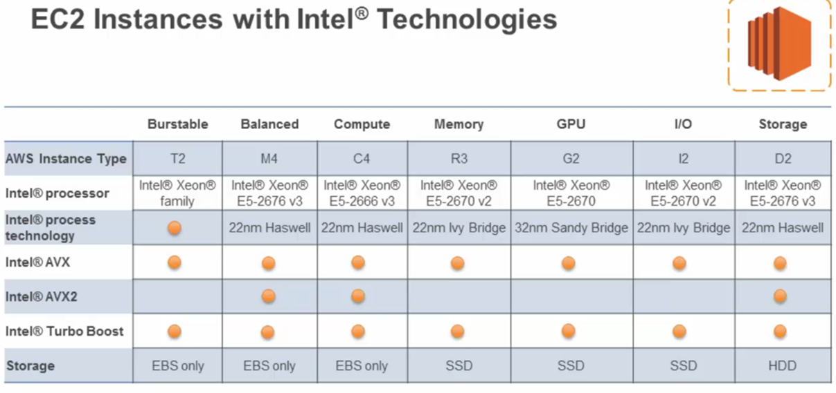

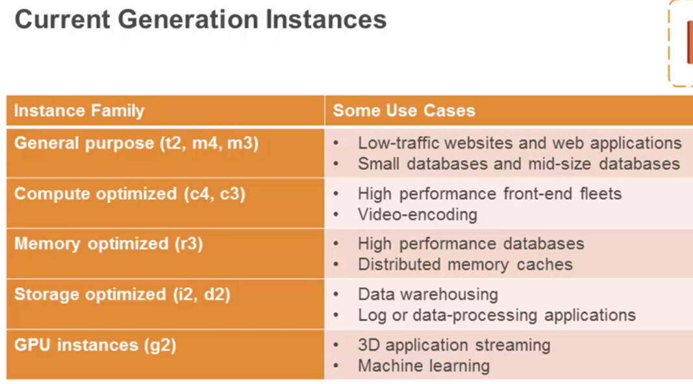

## Section 3, Lecture 14 Instance Metadata and User Data

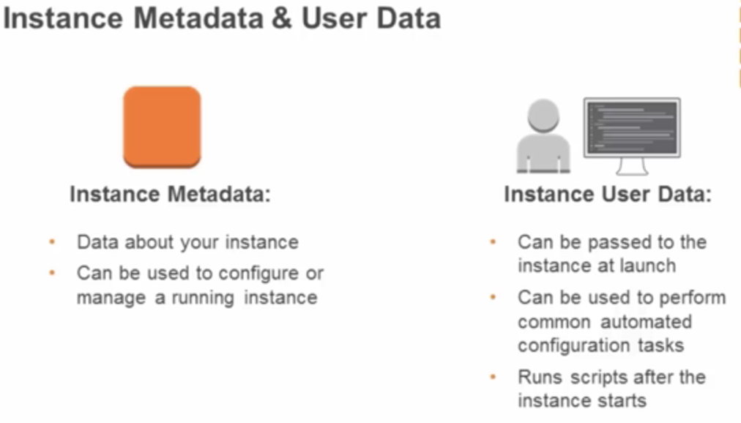

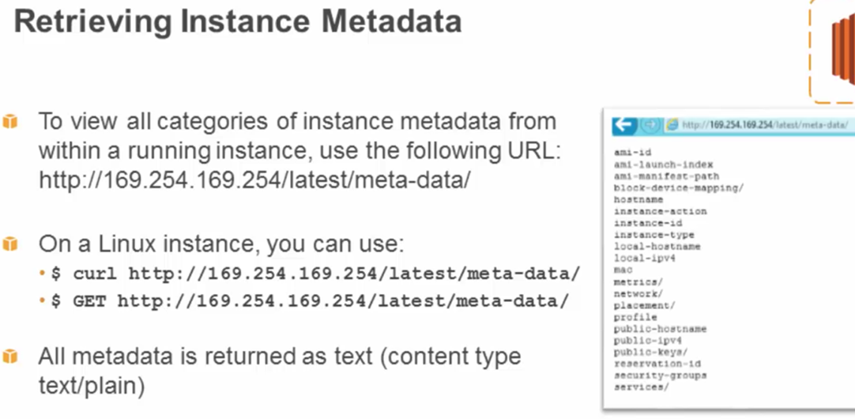

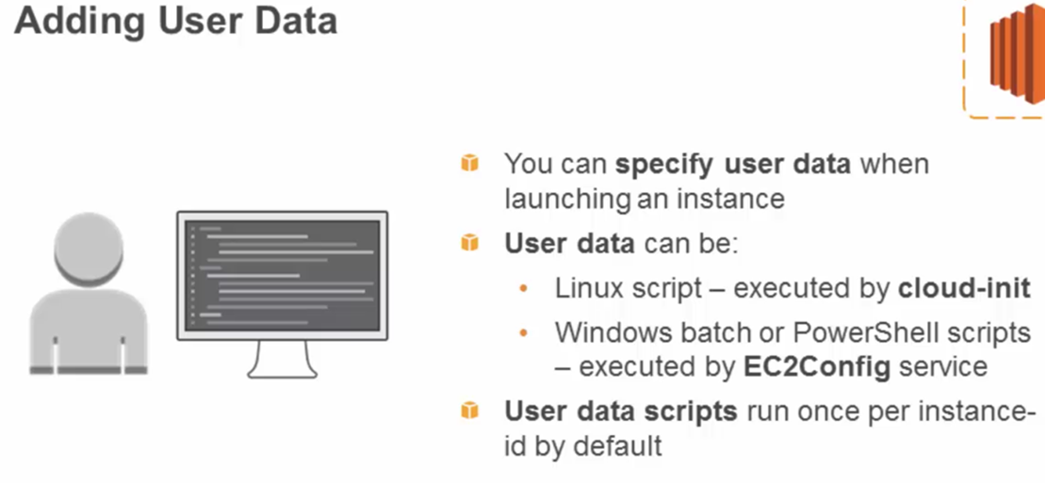

User data is limited to 16 KB

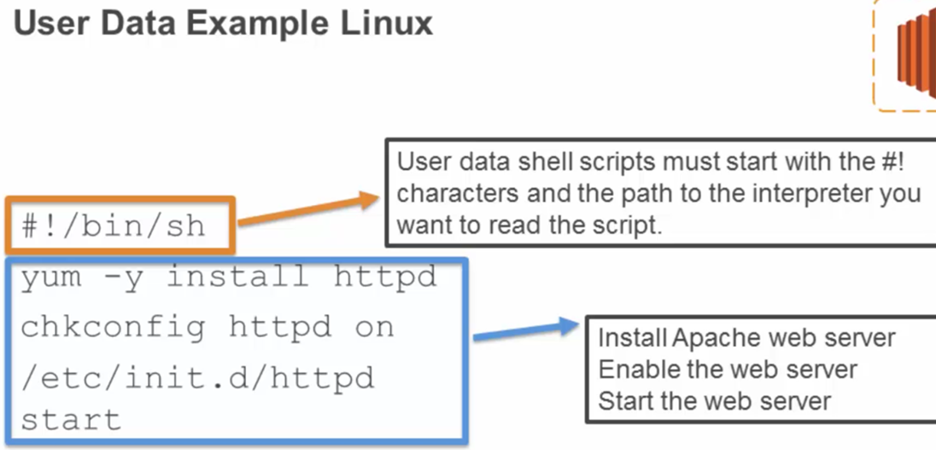

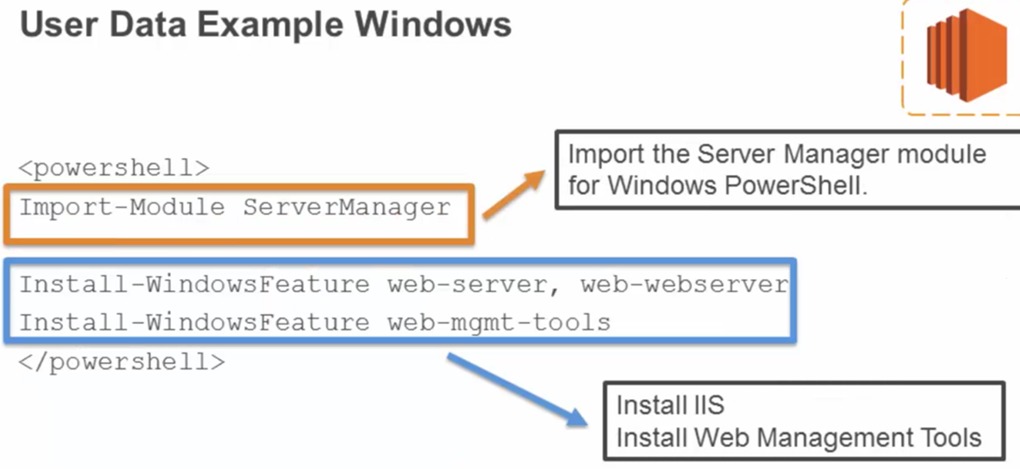

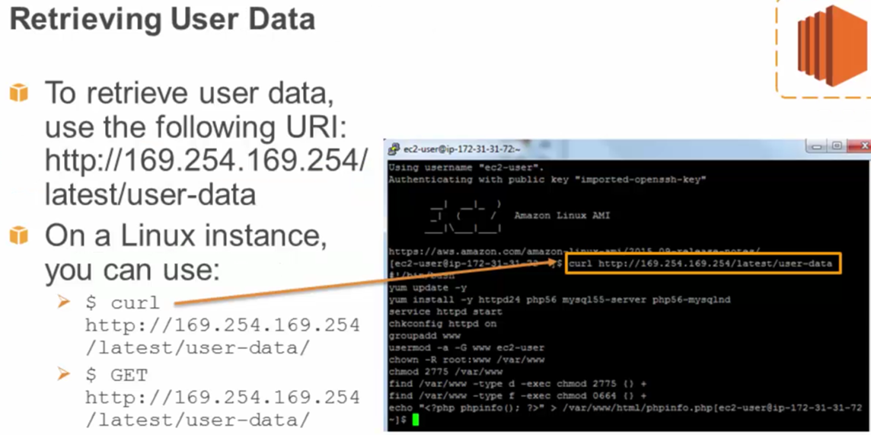

## Section 3, Lecture 15 Amazon EC2 Purchase Options

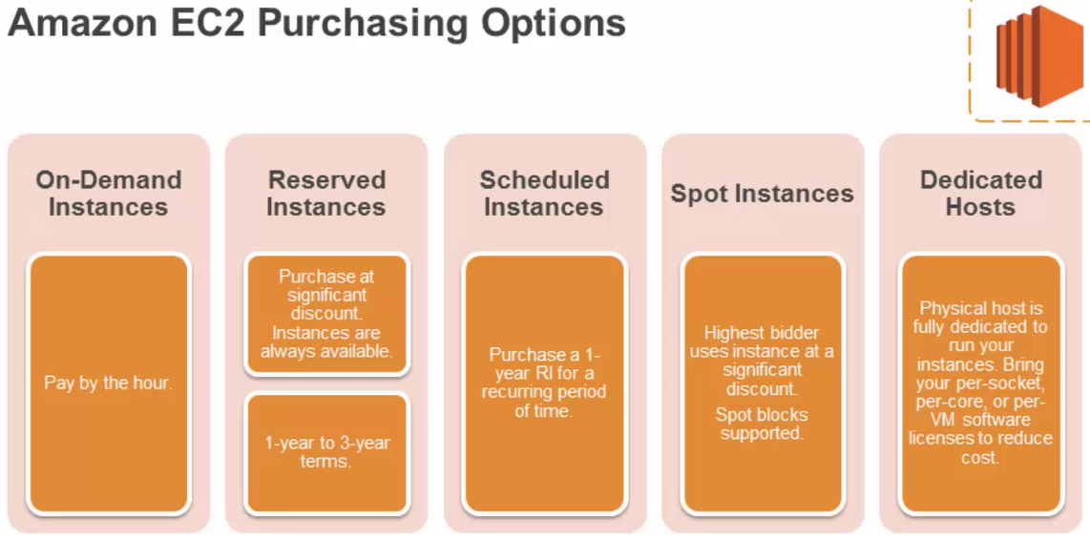

## Section 3, Lecture 16 Amazon Storage Services: Amazon S3

### Amazon S3: Simple Storage Service

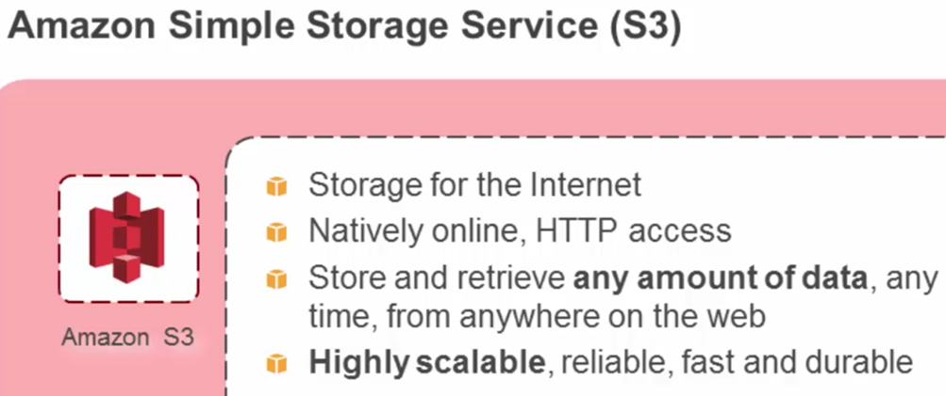

## Section 3, Lecture 17 Amazon Storage Services: Amazon S3

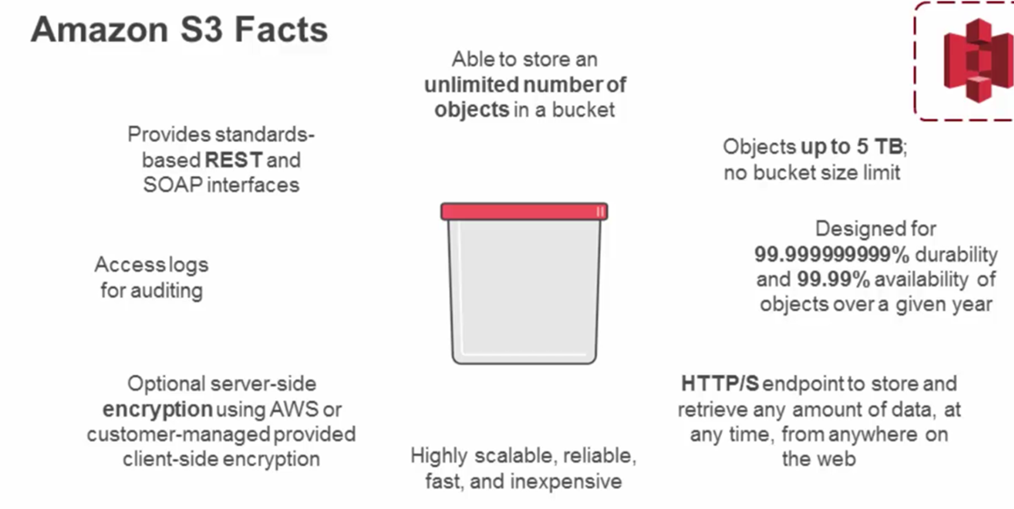

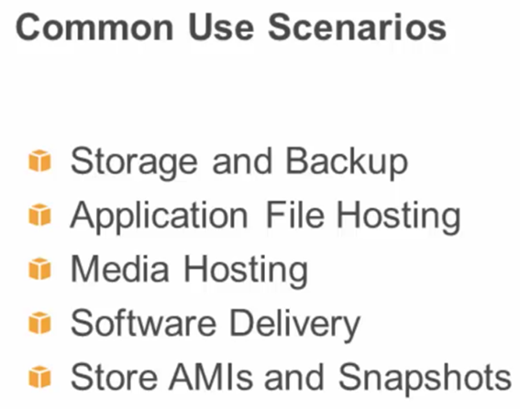

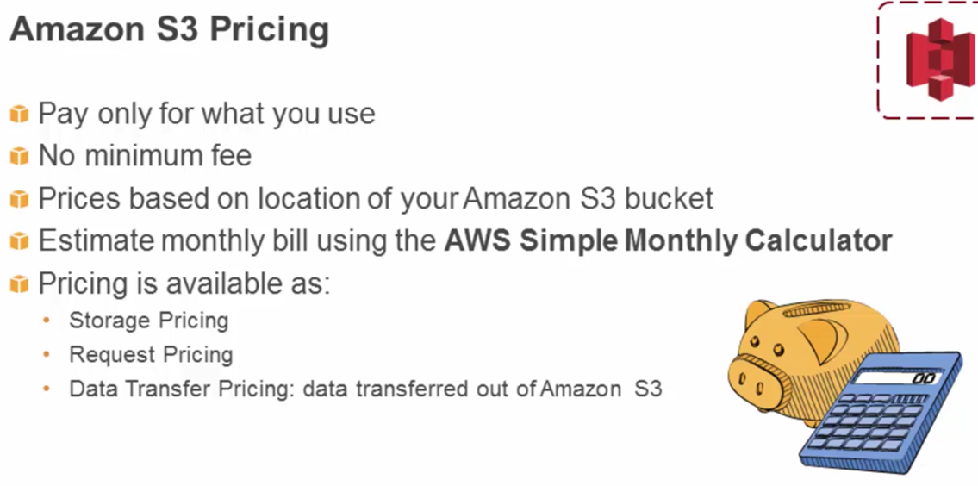

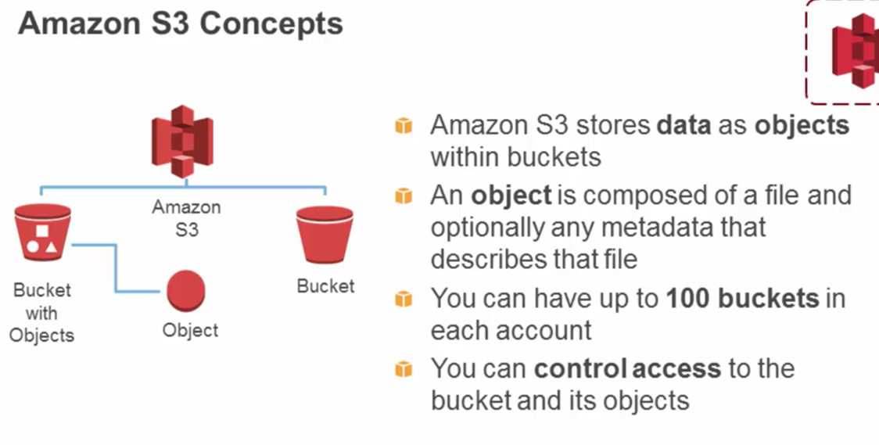

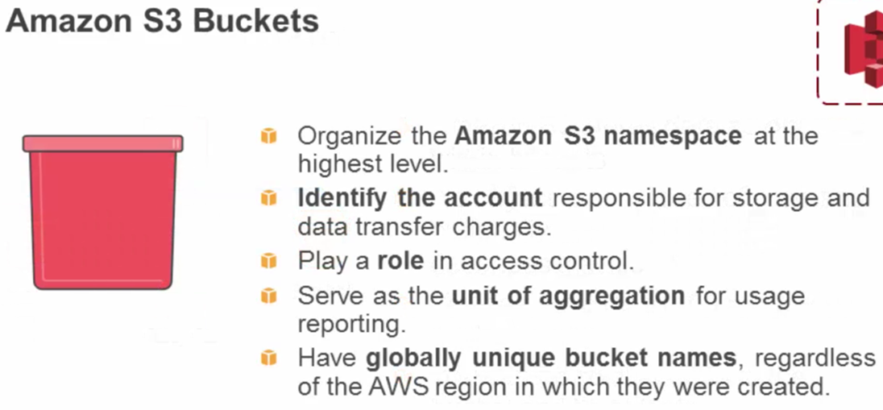

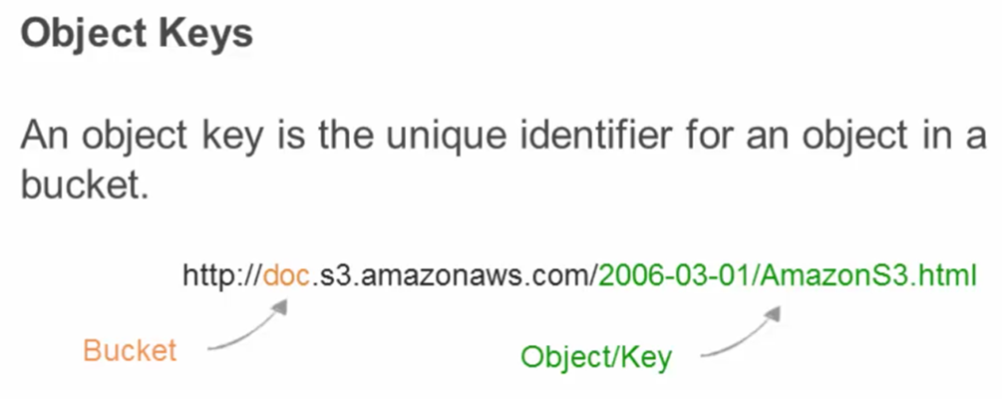

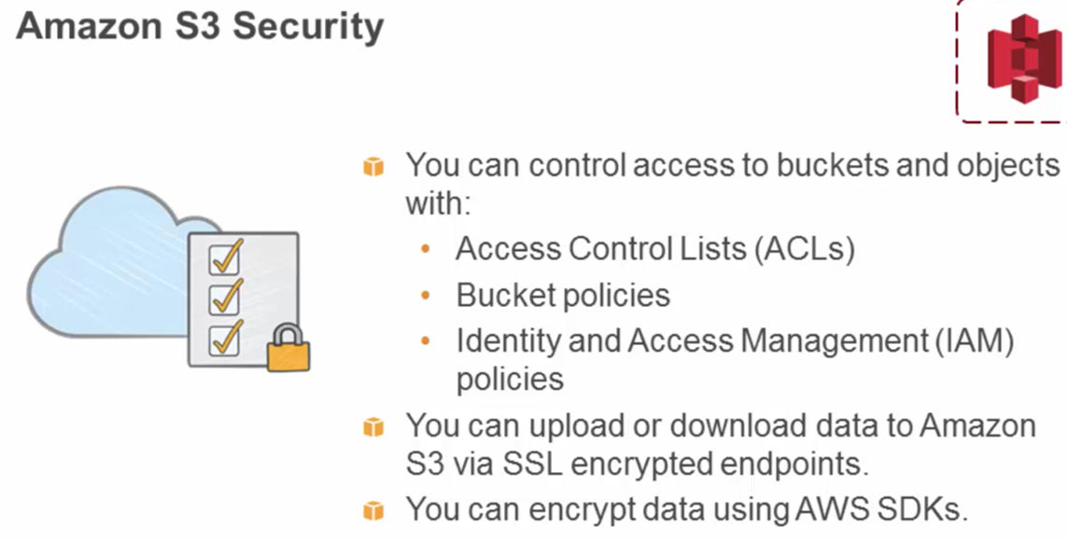

Amazon EBS: Elastic Block Storage Service

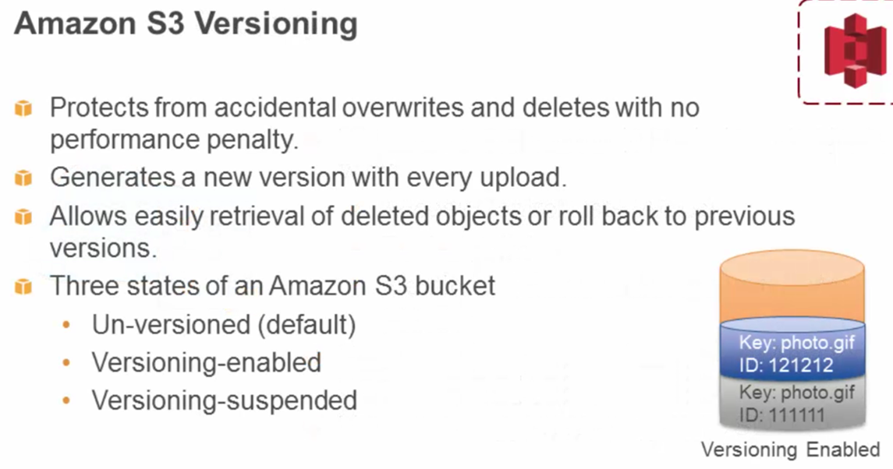

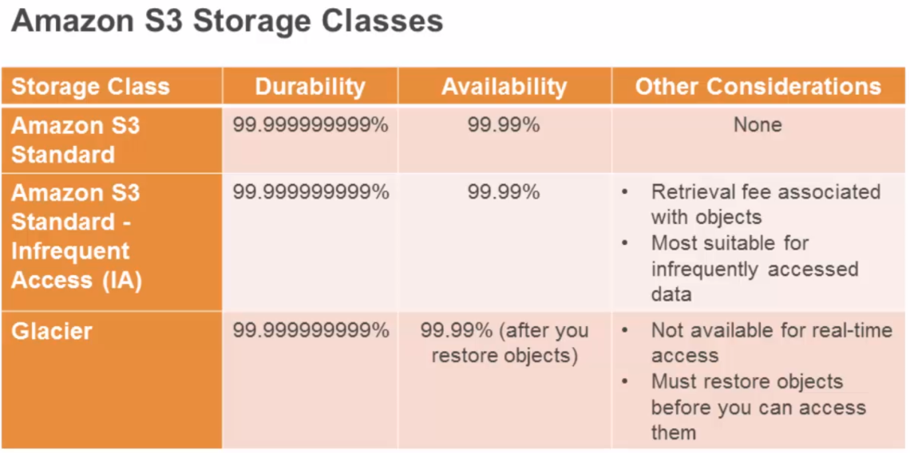

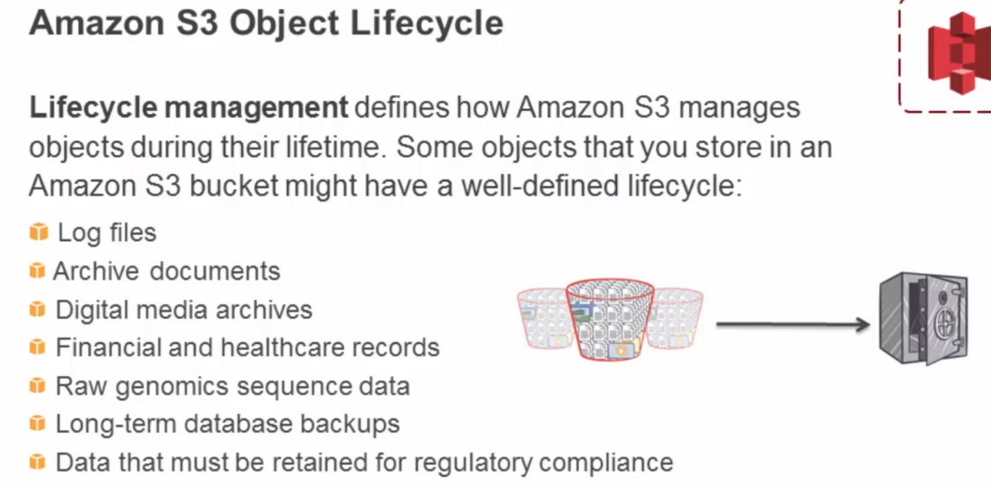

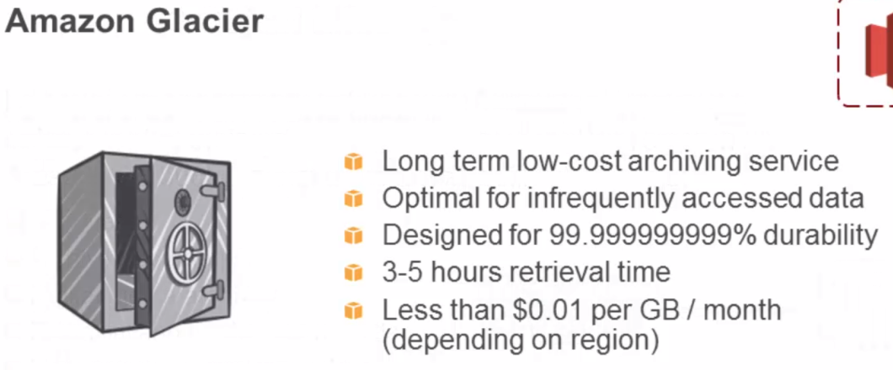

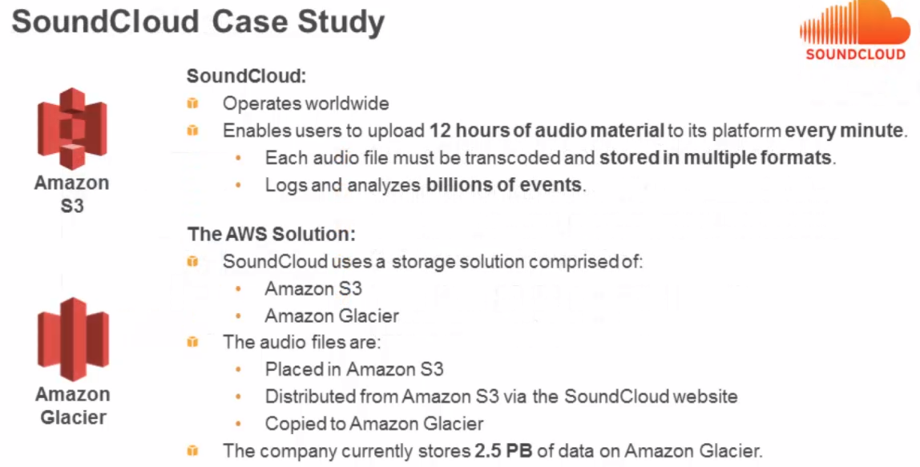

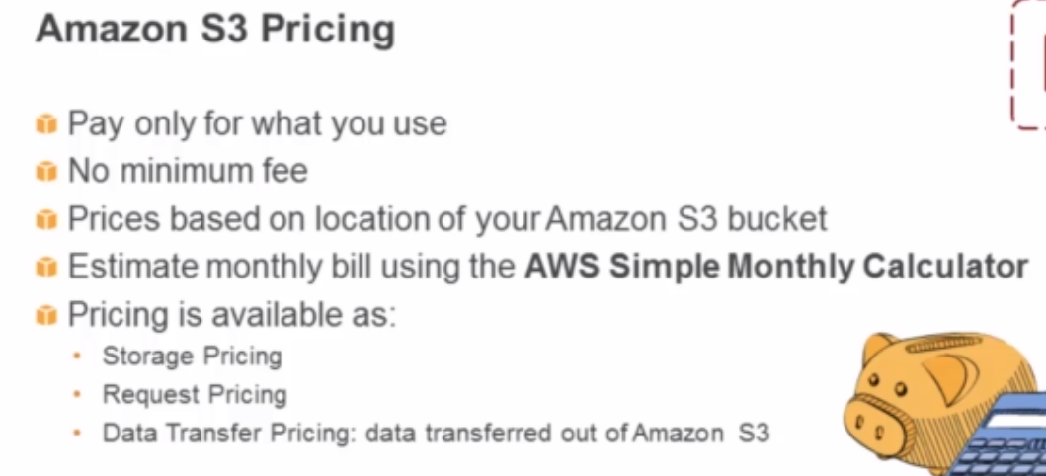

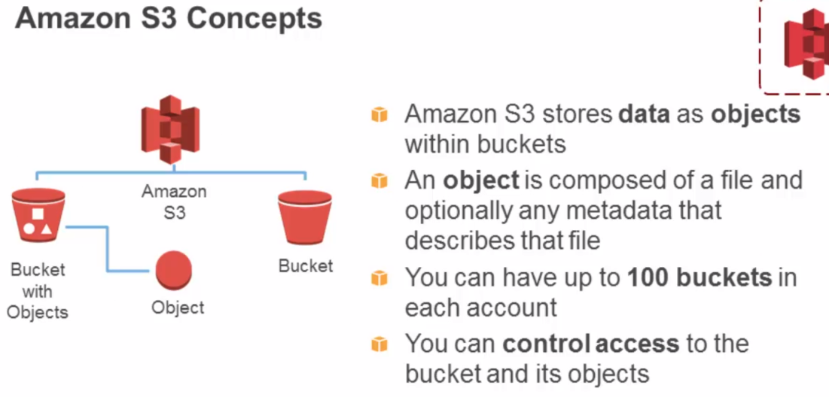

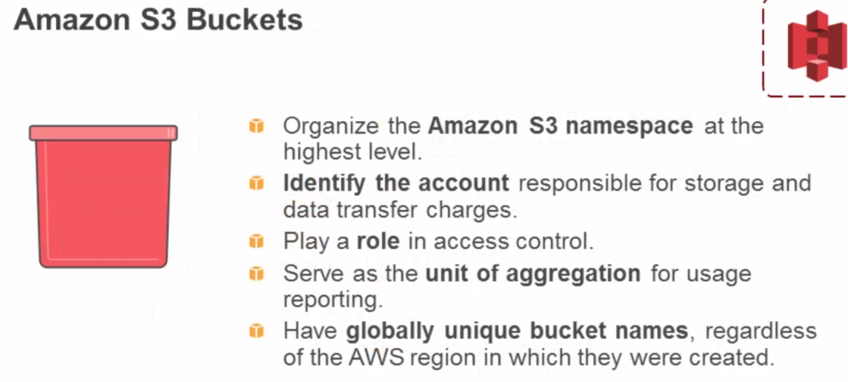

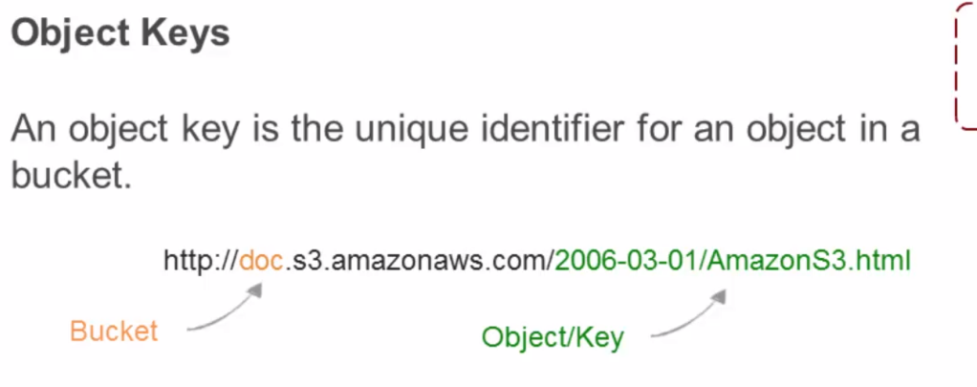

## Section 3, Lecture 22 Amazon EBS

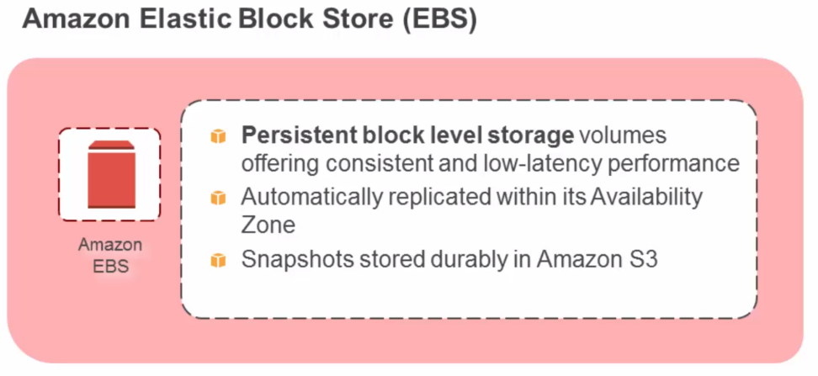

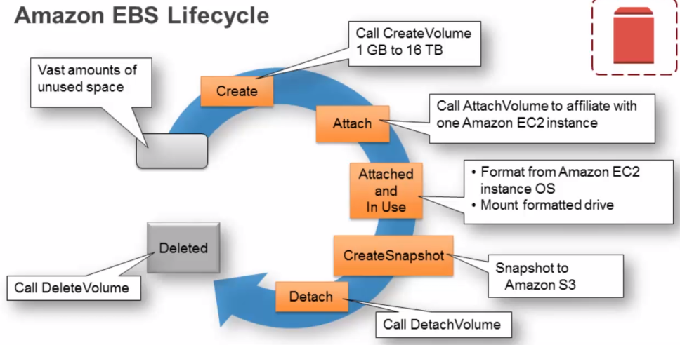

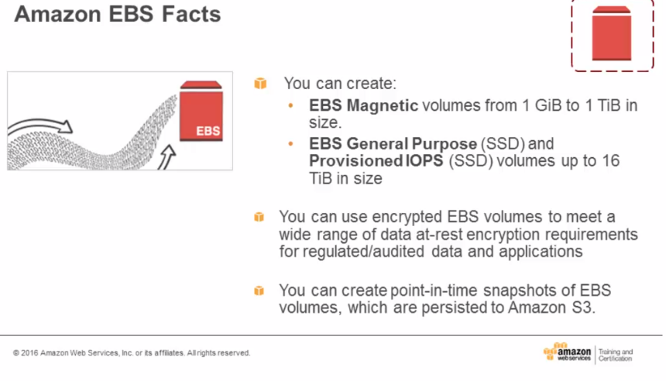

EBS is like a virtual harddrive

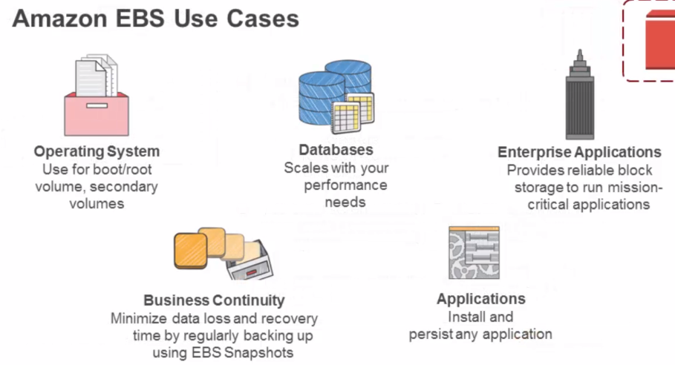

## Section 3, Lecture 23 EBS Pricing and Volumes

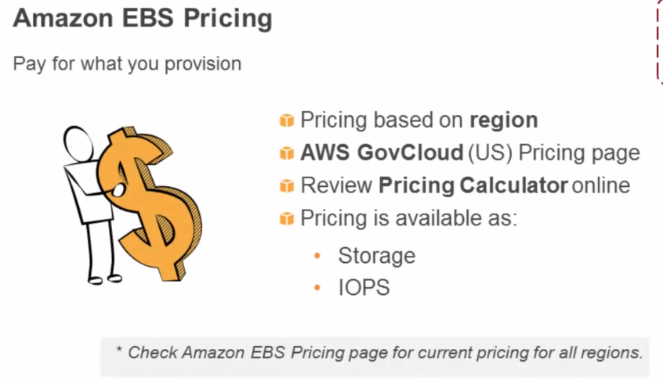

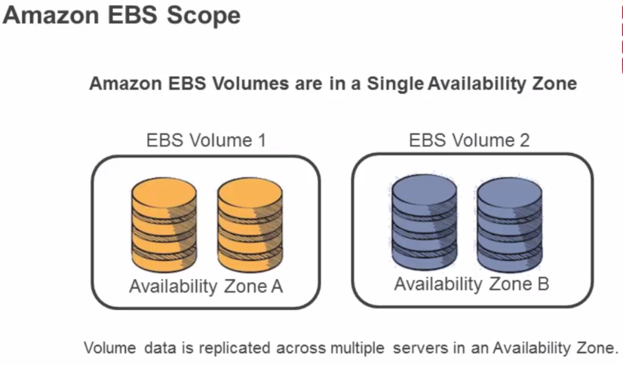

## Section 3, Lecture 24 Amazon EBS and S3

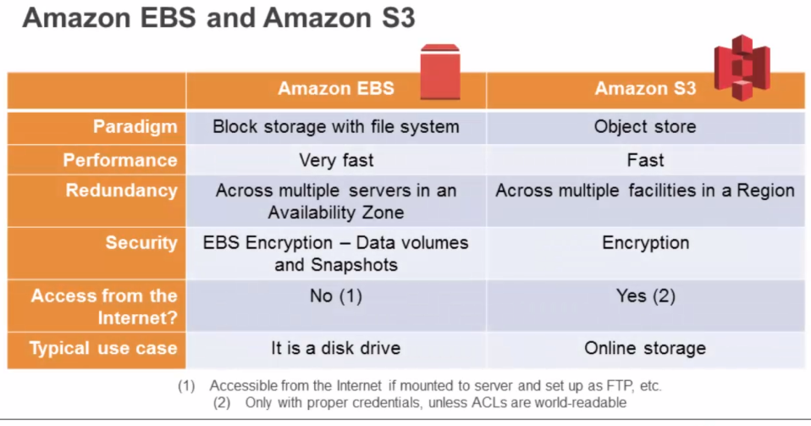

## Section 3, Lecture 25 Amazon EC2 Instance Store and Reboot

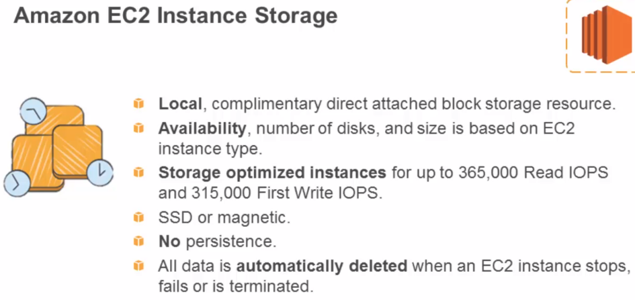

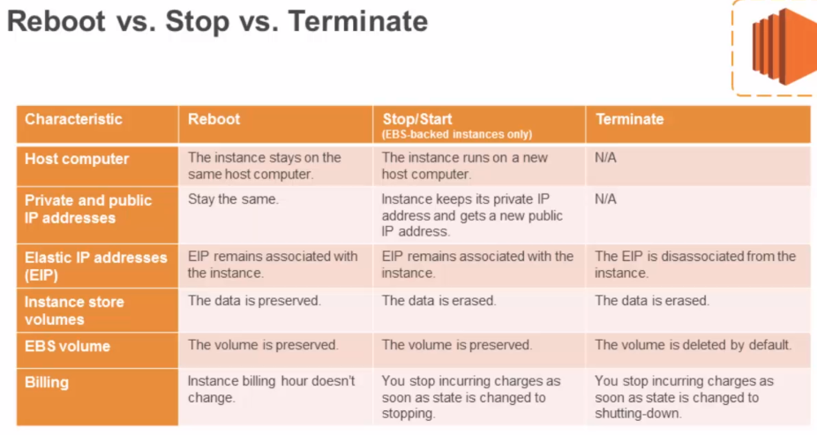

## Section 3, Lecture 26 Networking

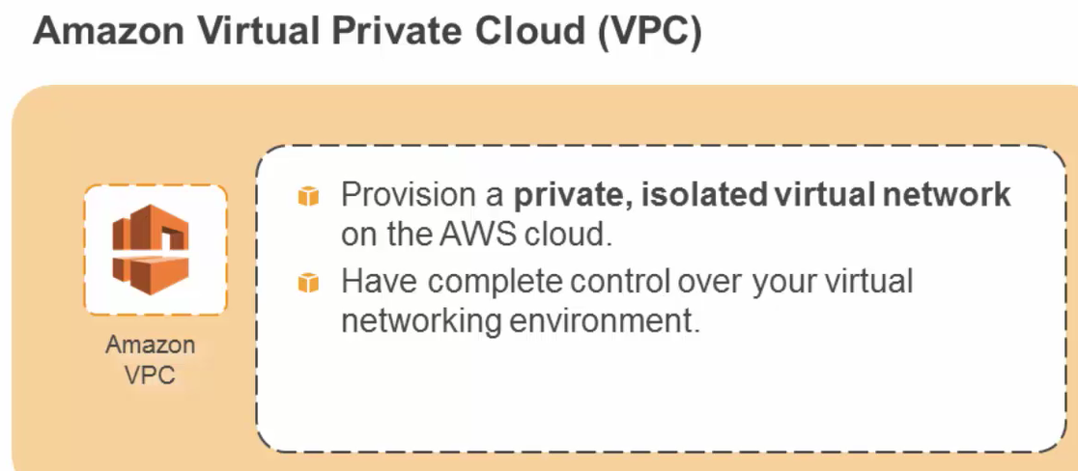

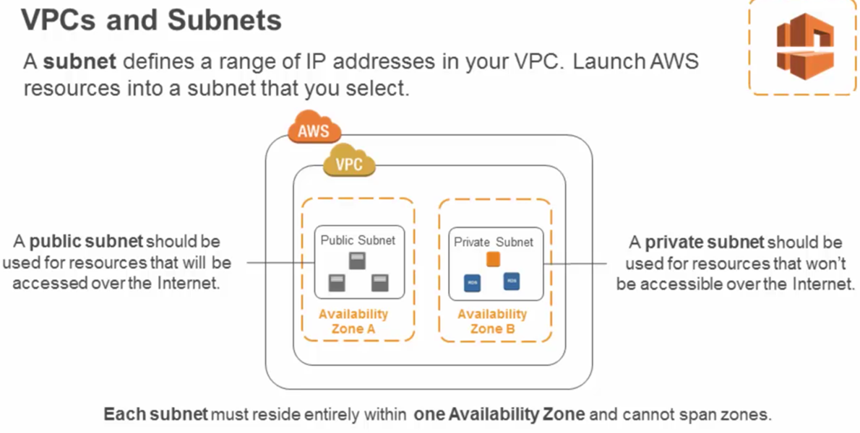

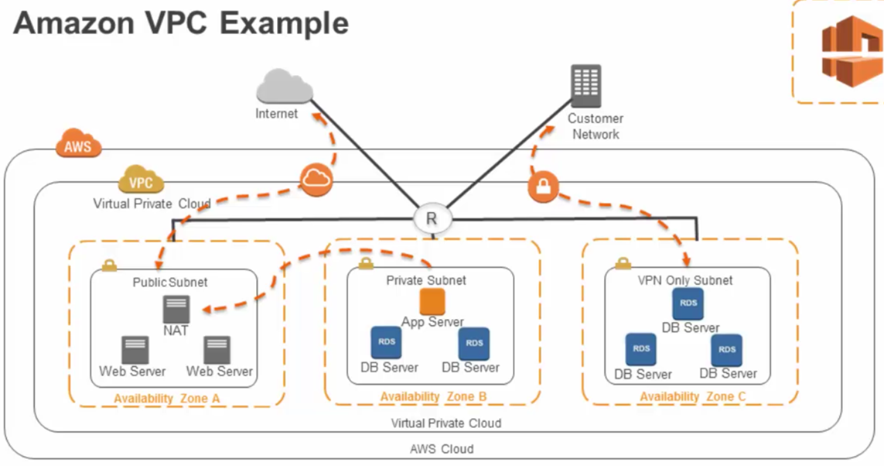

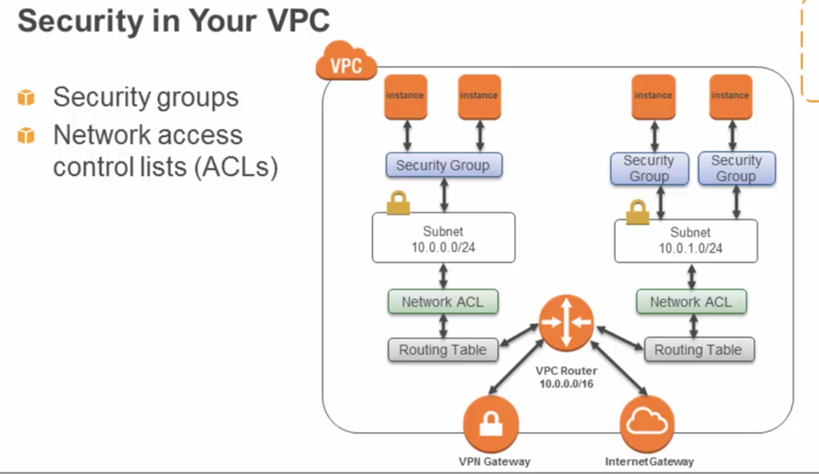

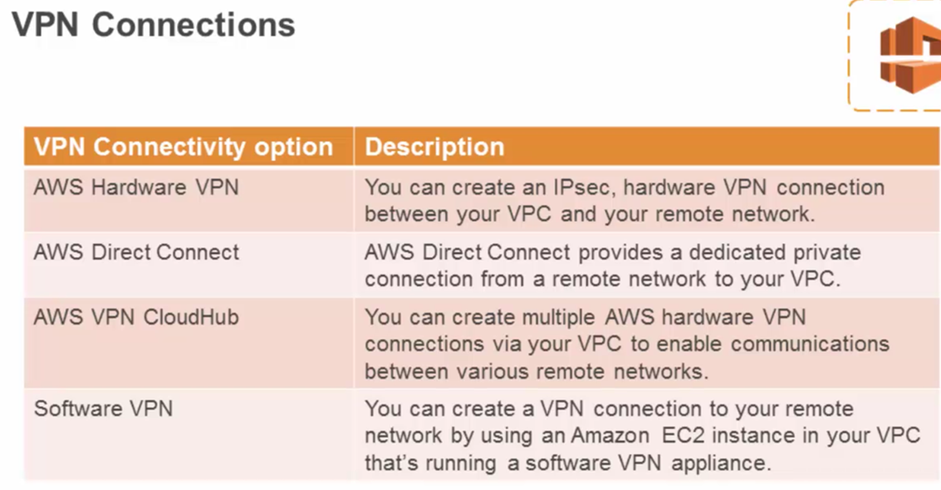

# Section 4: Security and Identity & Access Management

## Section 4, Lecture 29 Shared Security Model

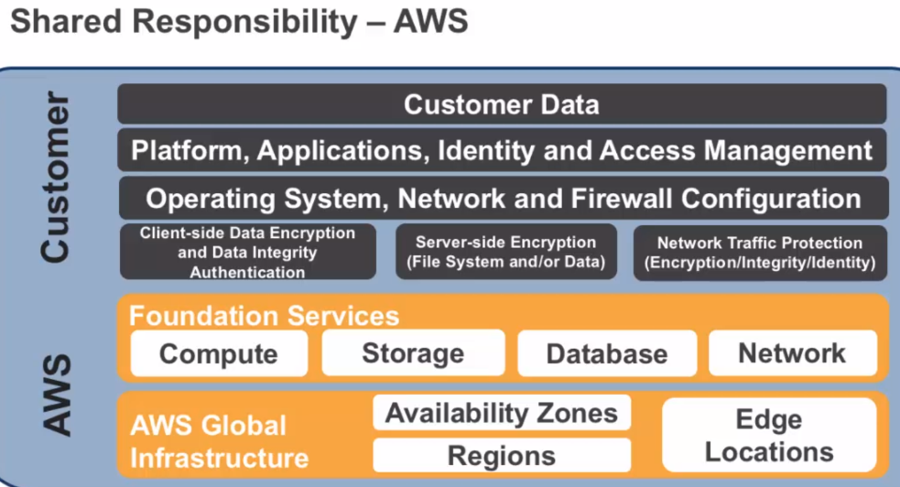

## Section 4, Lecture 30 Physical Security

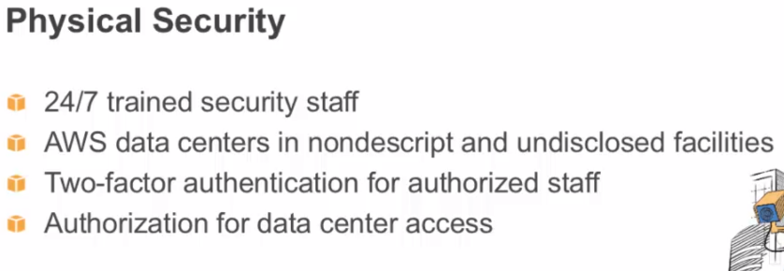

<https://aws.amazon.com/security/>

## Section 4, Lecture 31 Hardware Software Auditing and Compliance

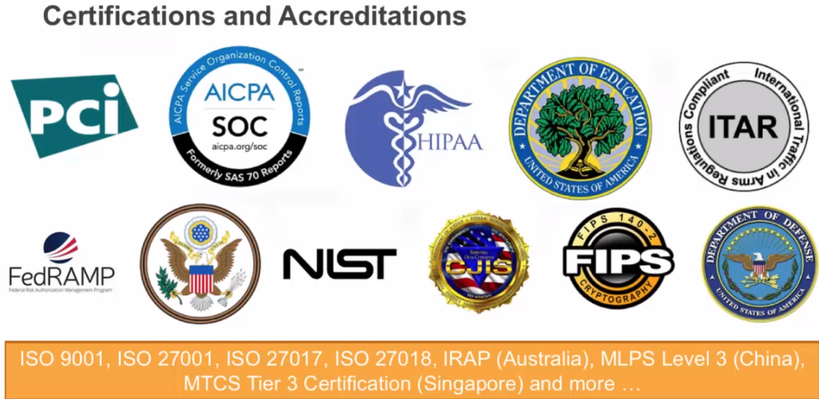

## Section 4, Lecture 32 Security Groups

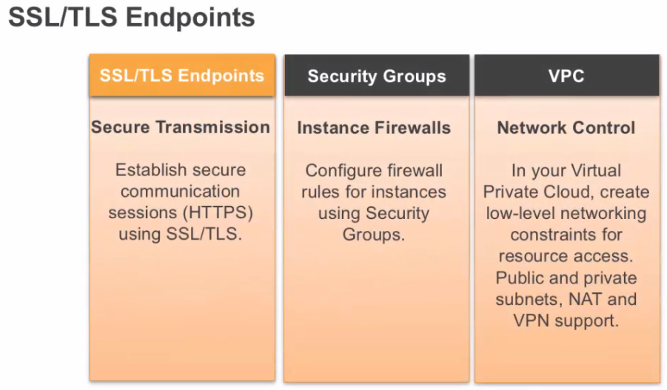

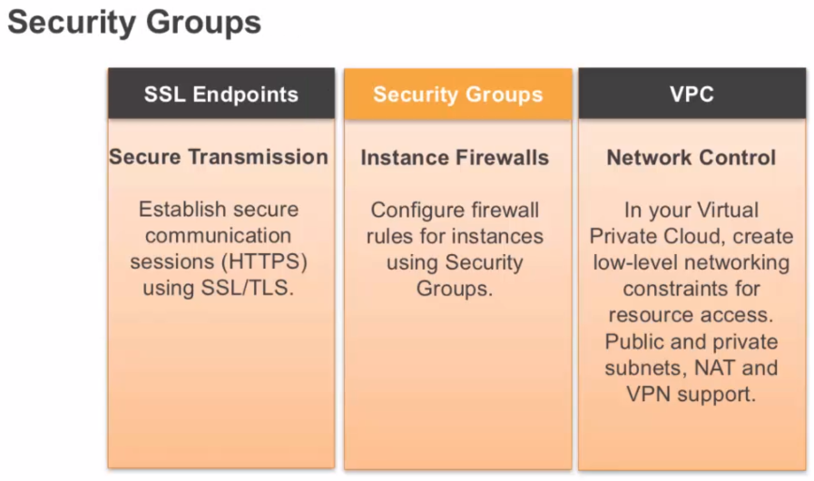

## Section 4, Lecture 33 Security Groups Explained

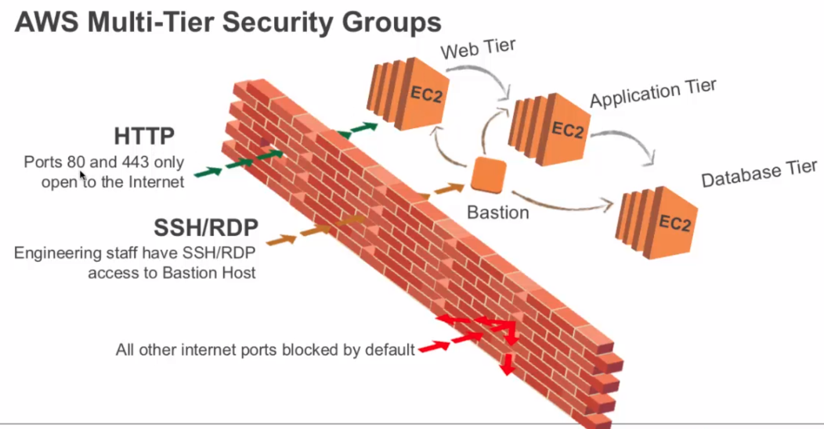

## Section 4, Lecture 34 Amazon VPC

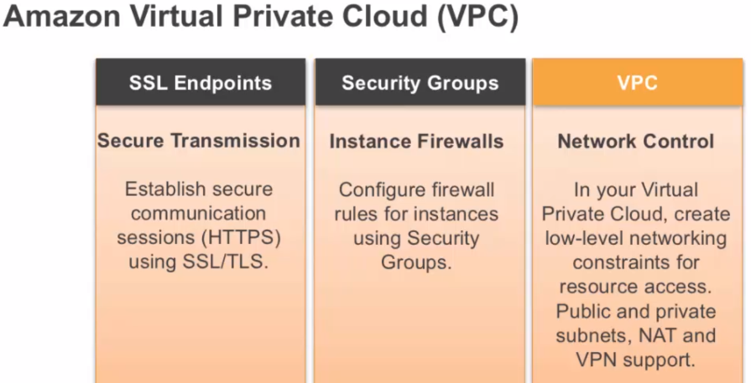

## Section 4, Lecture 35 Amazon IAM Authorization

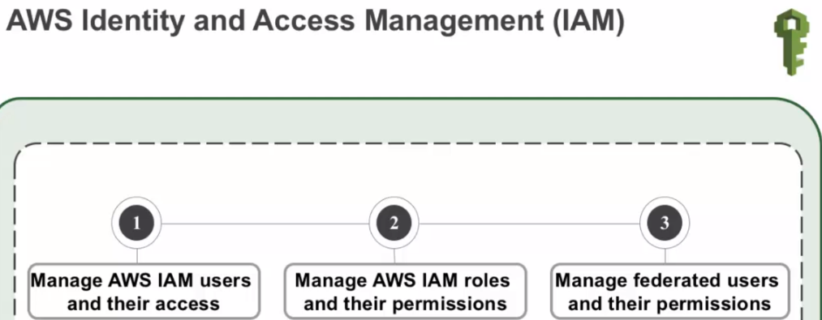

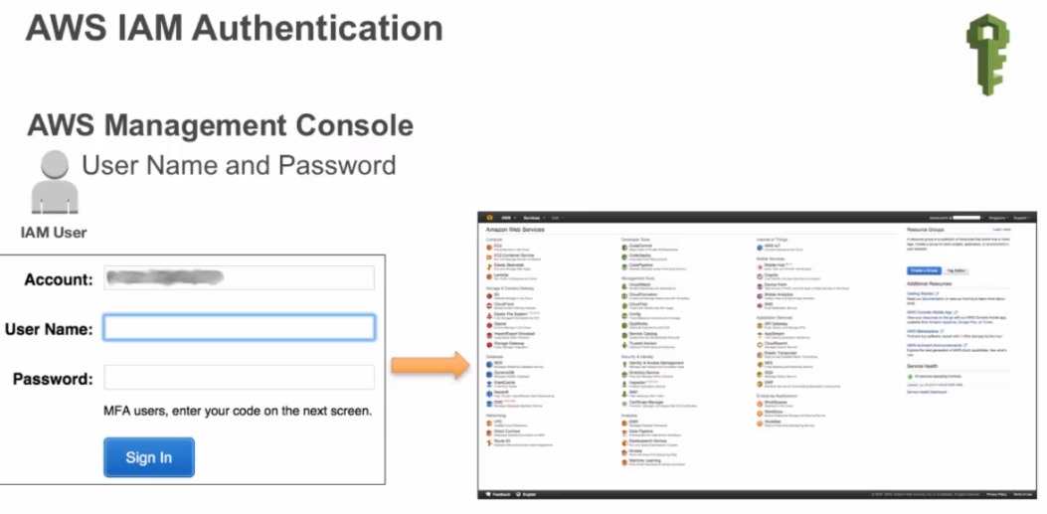

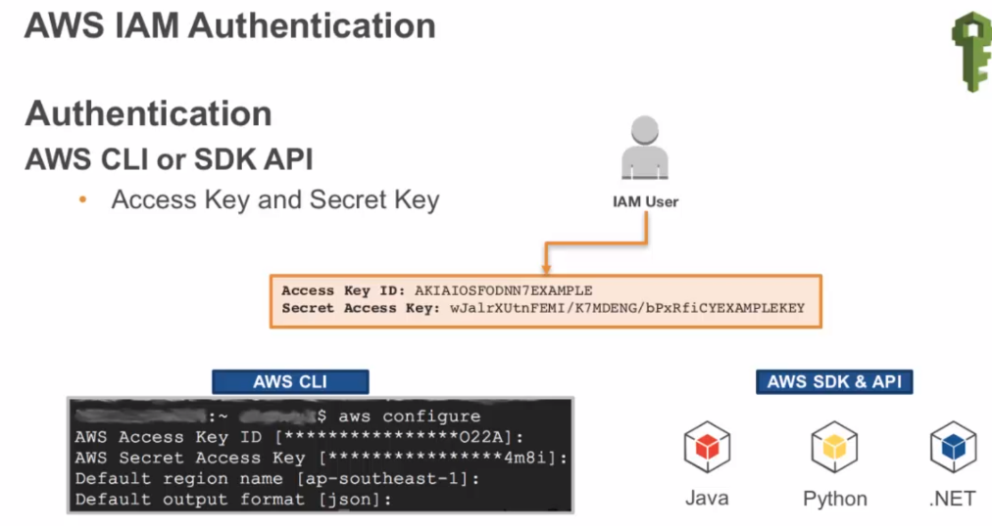

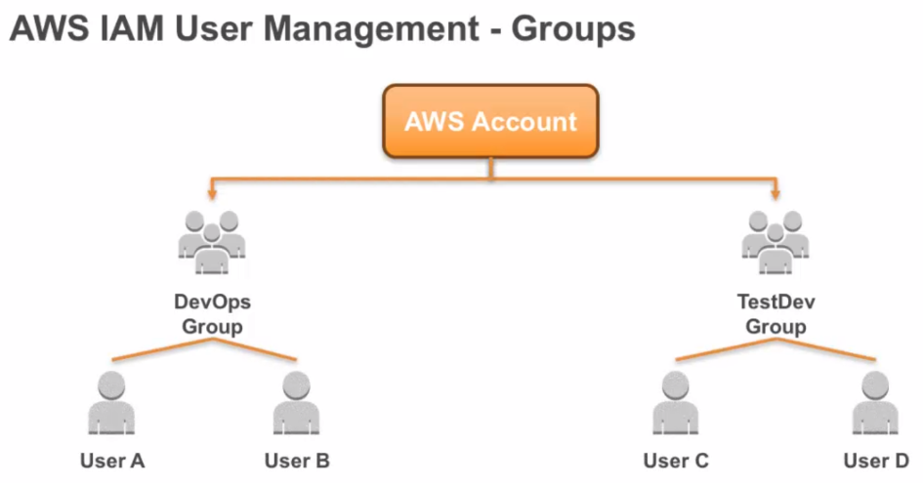

## Section 4, Lecture 36 Policies

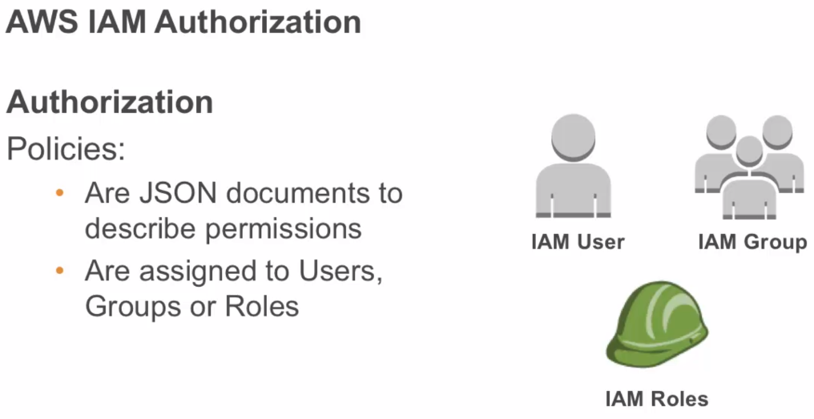

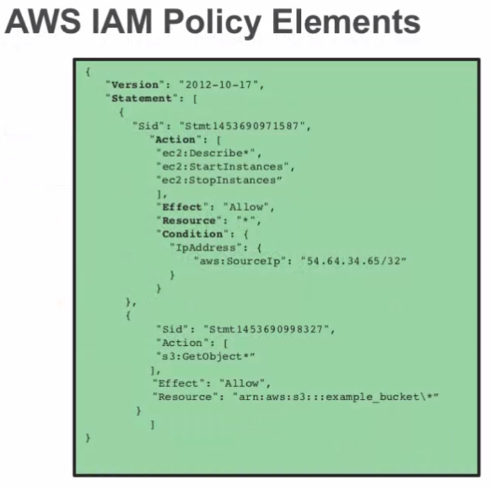

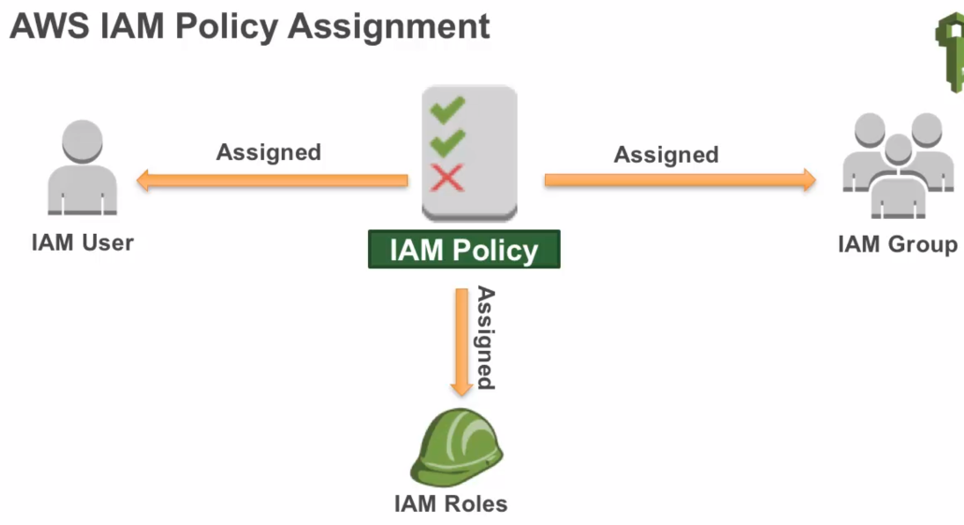

## Section 4, Lecture 37 Assume Role

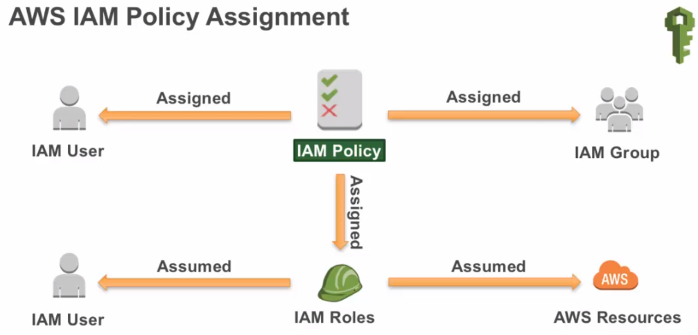

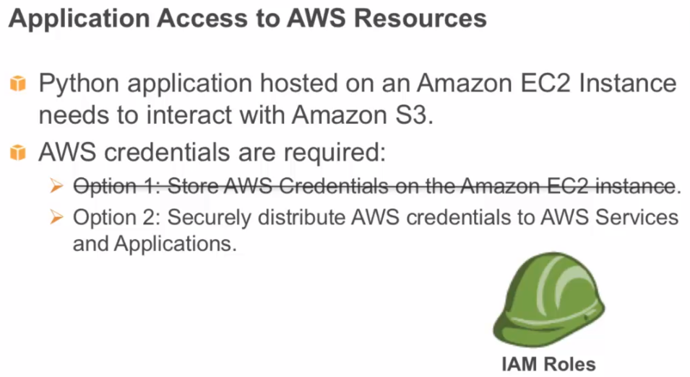

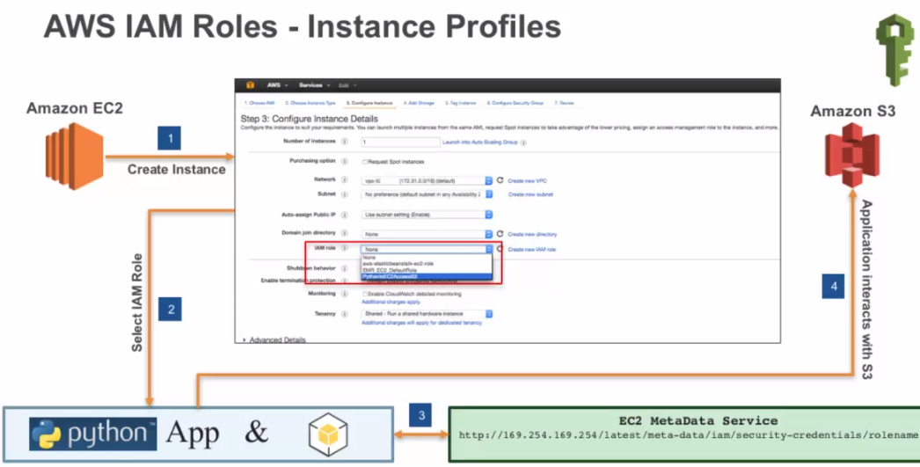

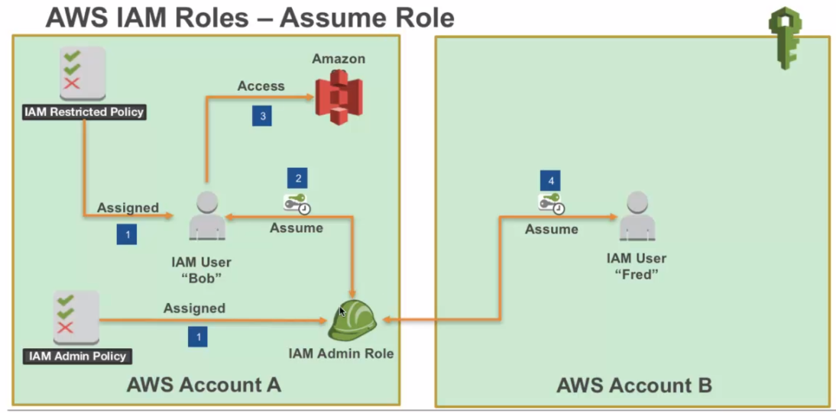

## Section 4, Lecture 39 Security Credentials and IAM Authorization

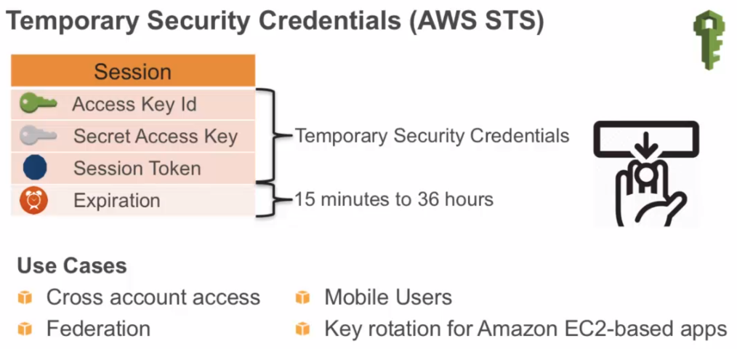

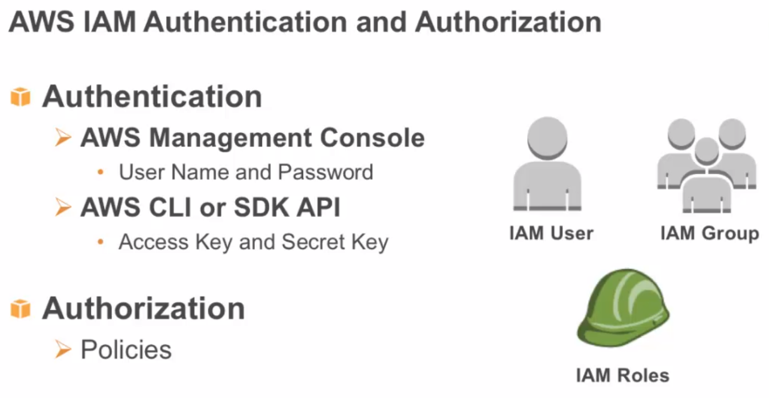

## Section 4, Lecture 40 Security Best Practices

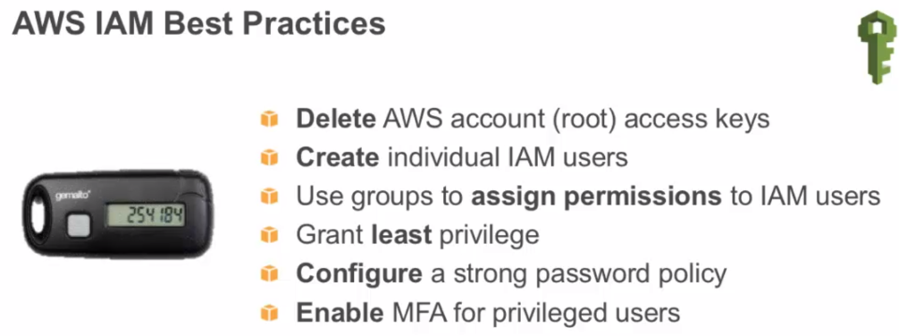

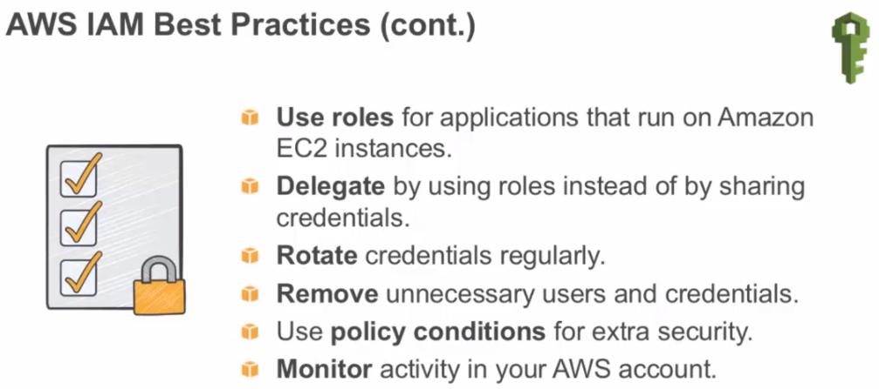

Monitoring – AWS Cloud Trail

## Section 4, Lecture 41 AWS Resource-Based Policies

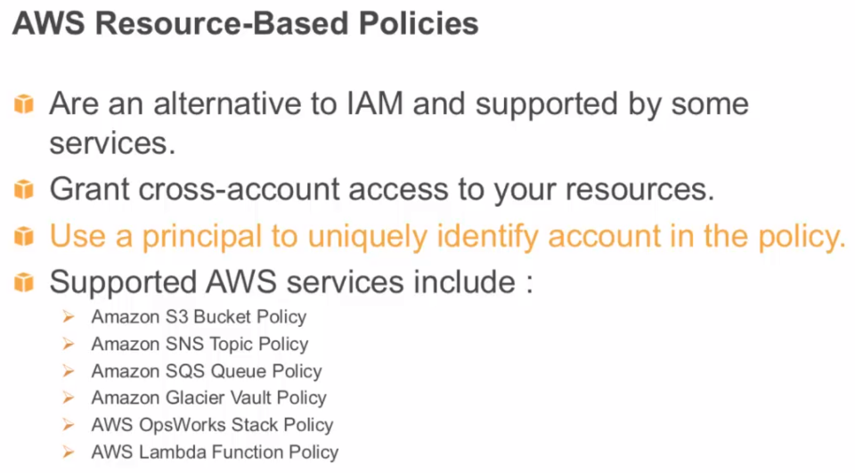

Focus on the principle of least priviledge.

## Section 5

## Section 5, Lecture 42 Introduction to AWS Databases

## Section 5, Lecture 43 AWS Databases

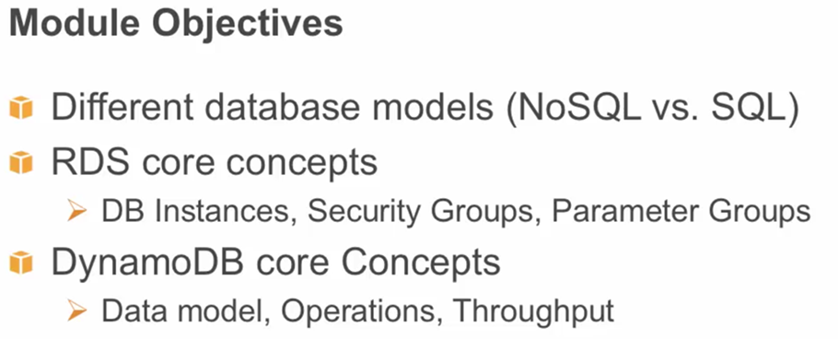

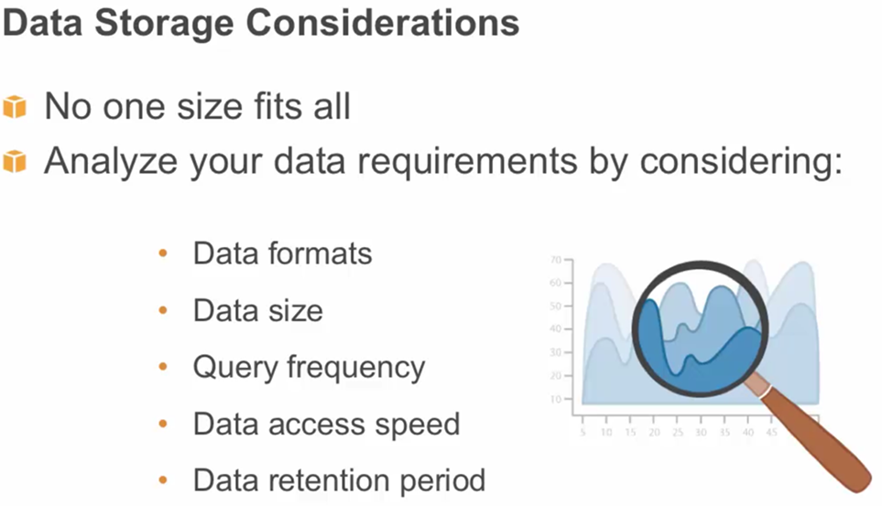

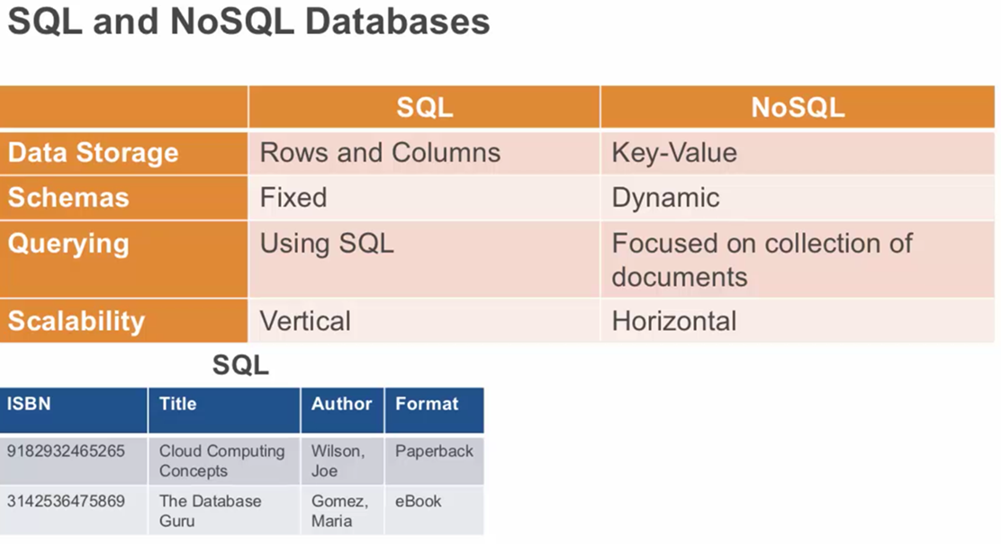

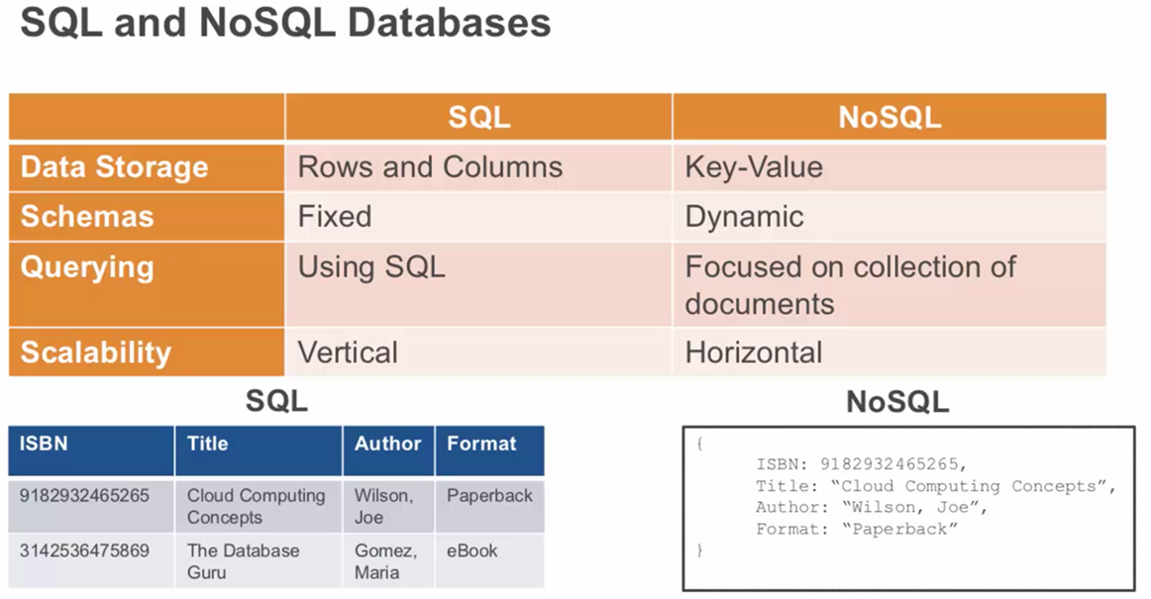

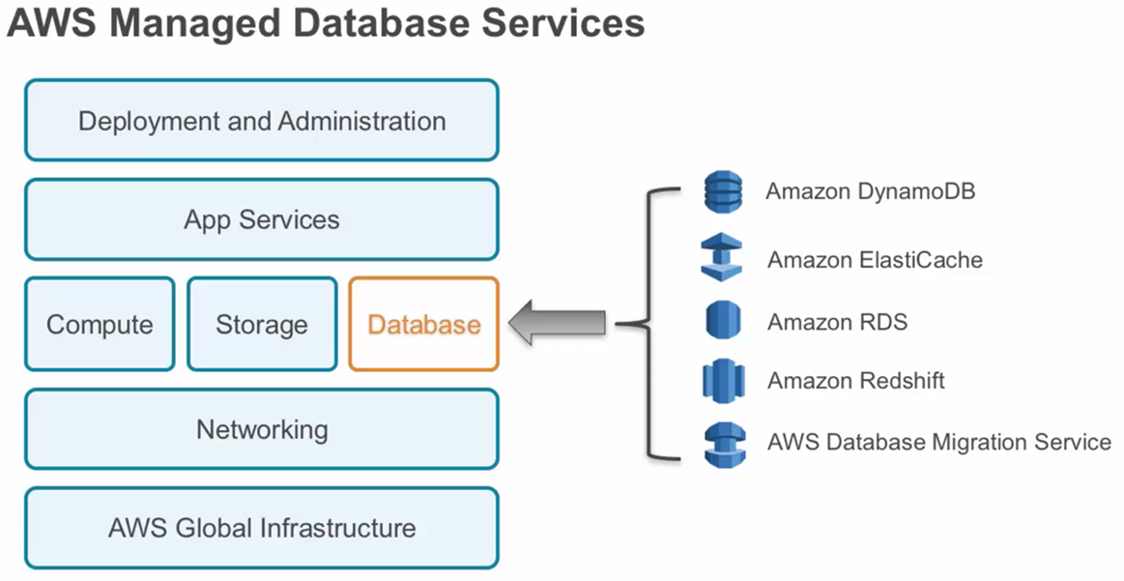

## Section 5, Lecture 44 Amazon RDS Concepts

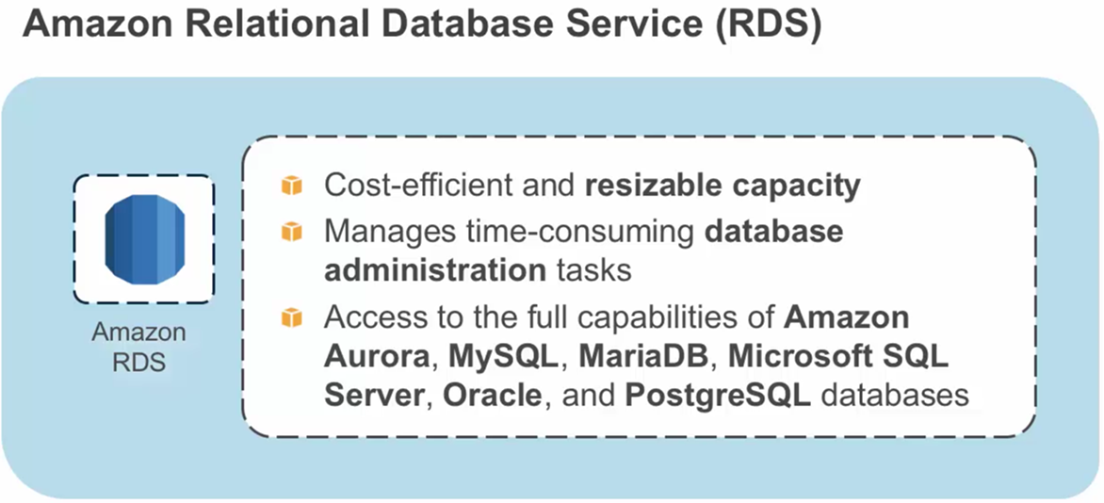

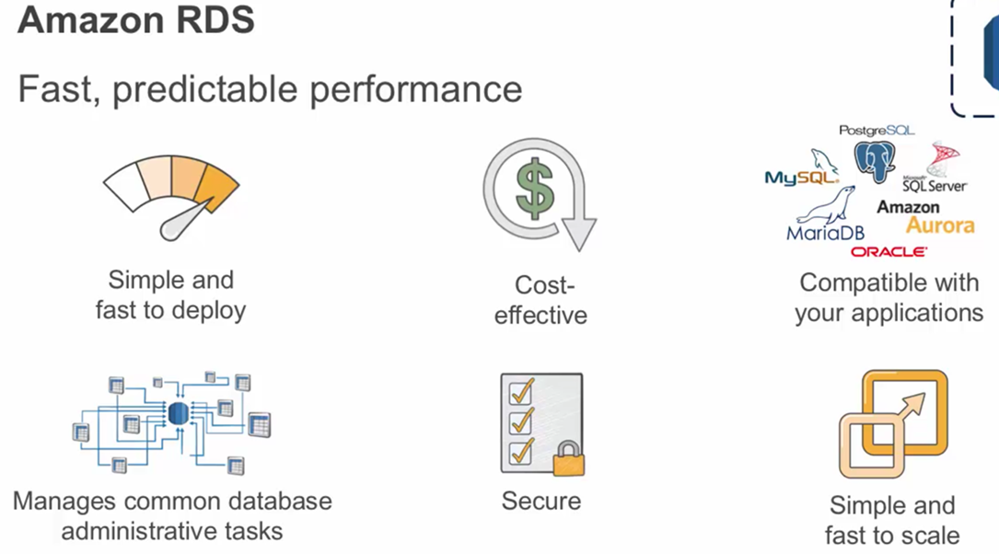

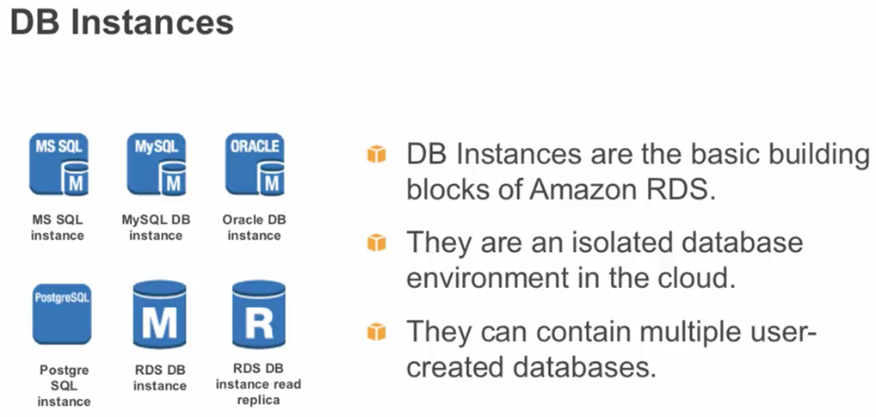

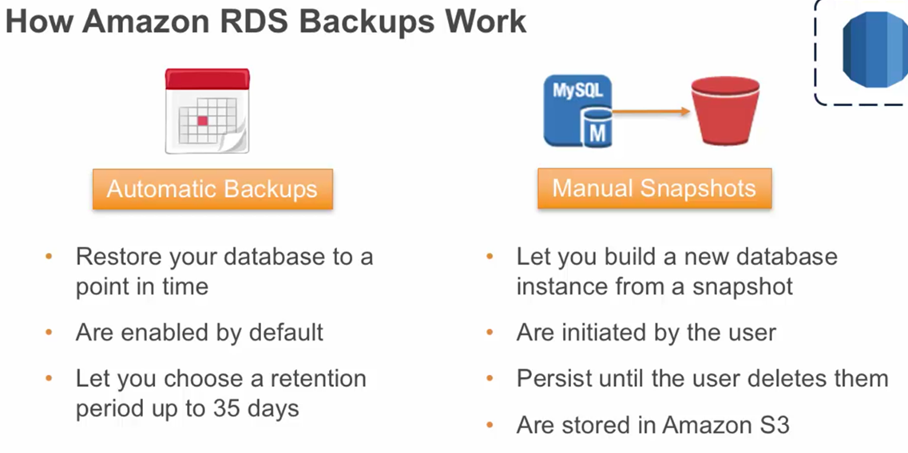

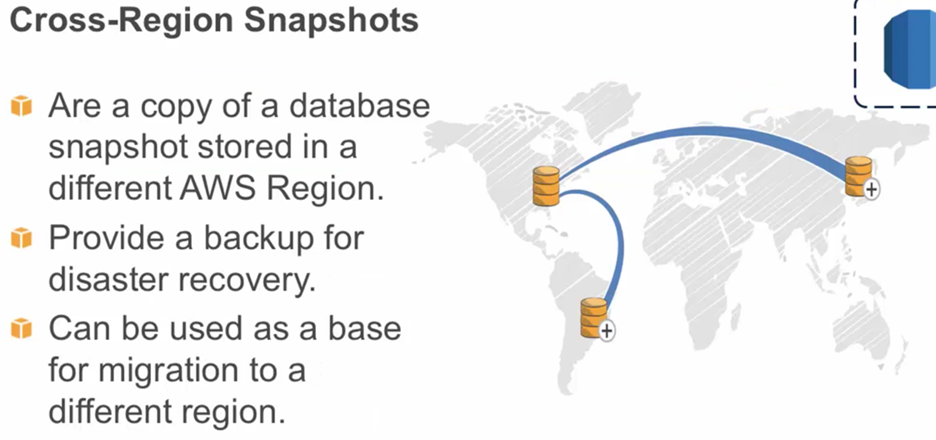

## Section 5, Lecture 45 Database Security

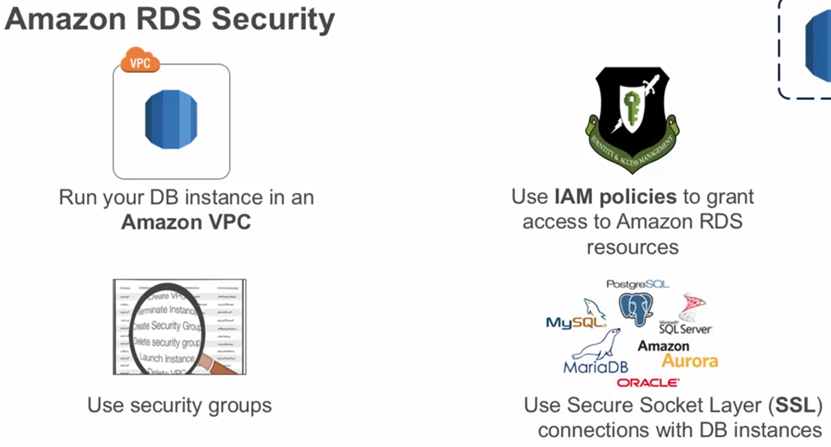

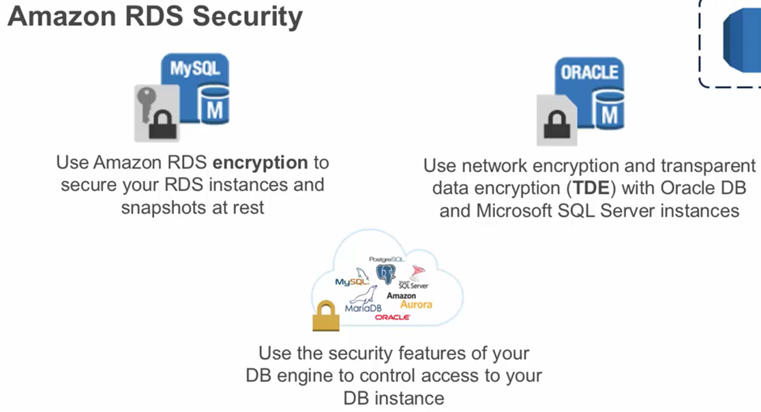

## Section 5, Lecture 46 Amazon RDS Architecture

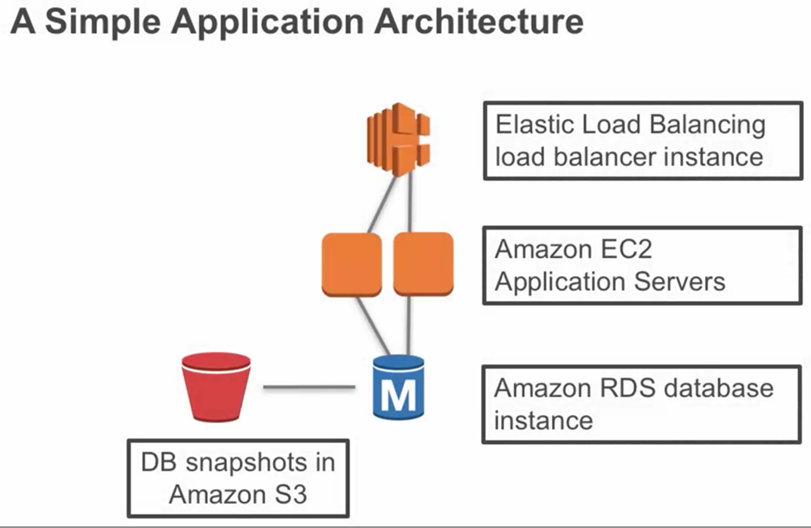

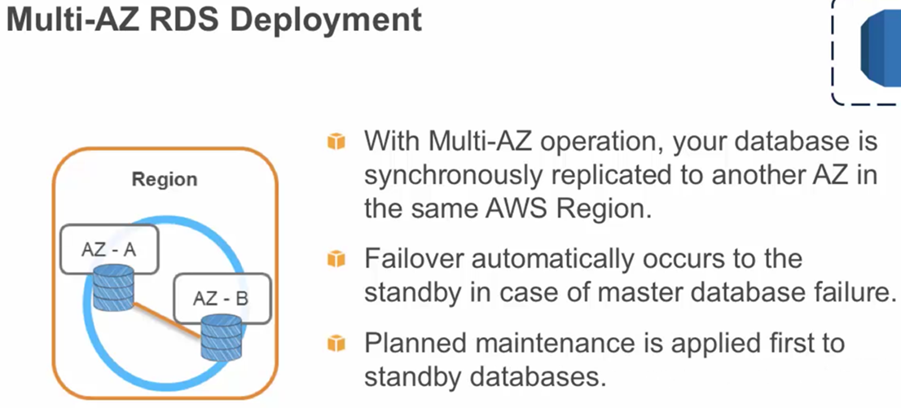

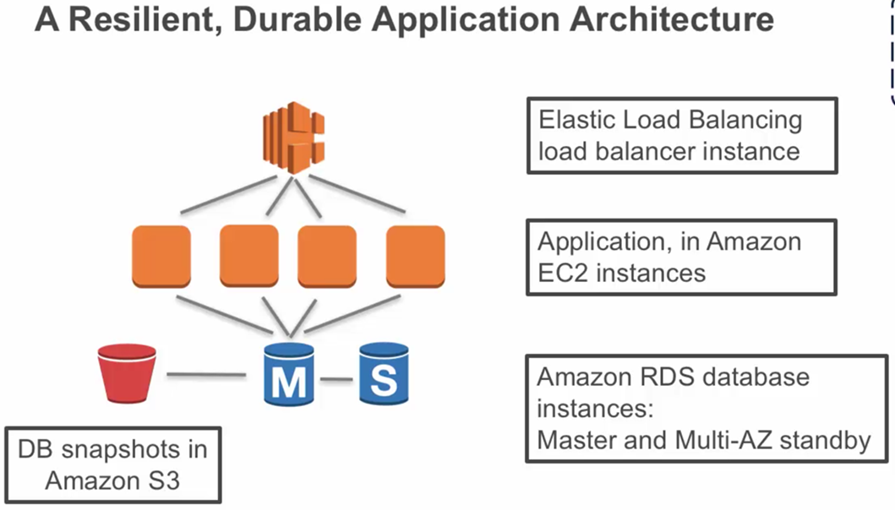

## Section 5, Lecture 47 Database Parameters

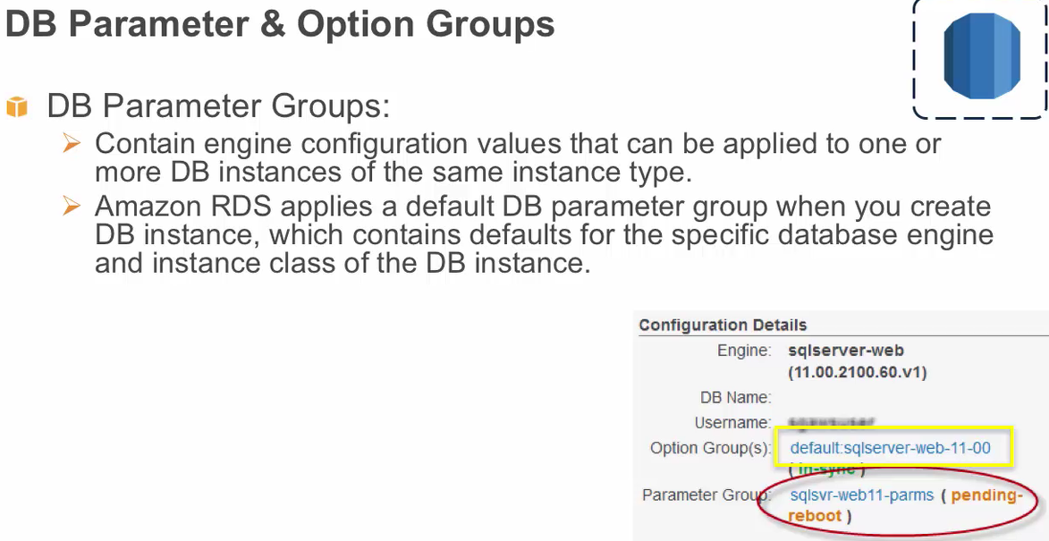

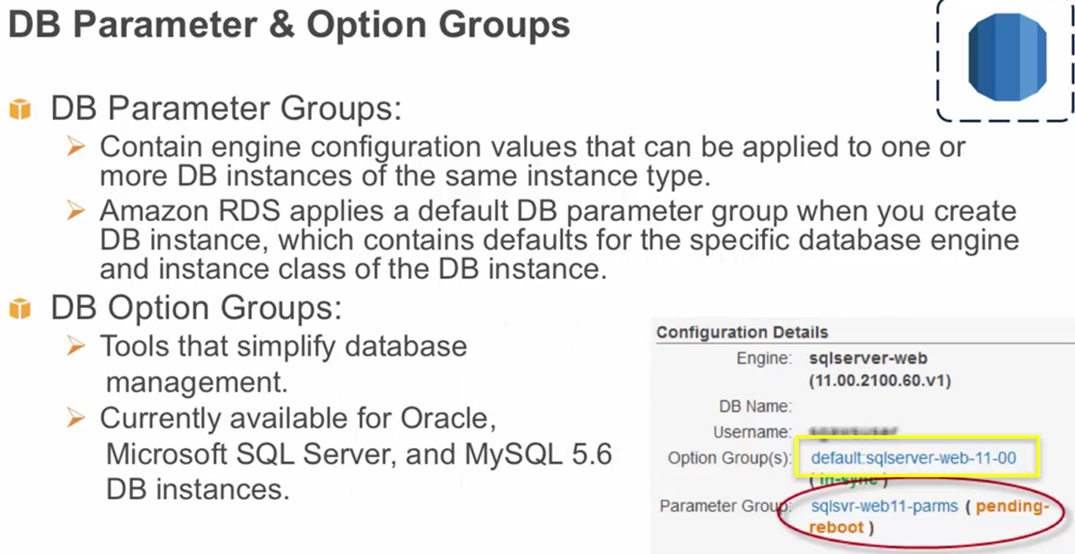

## Section 5, Lecture 48 Amazon RDS Best Practices

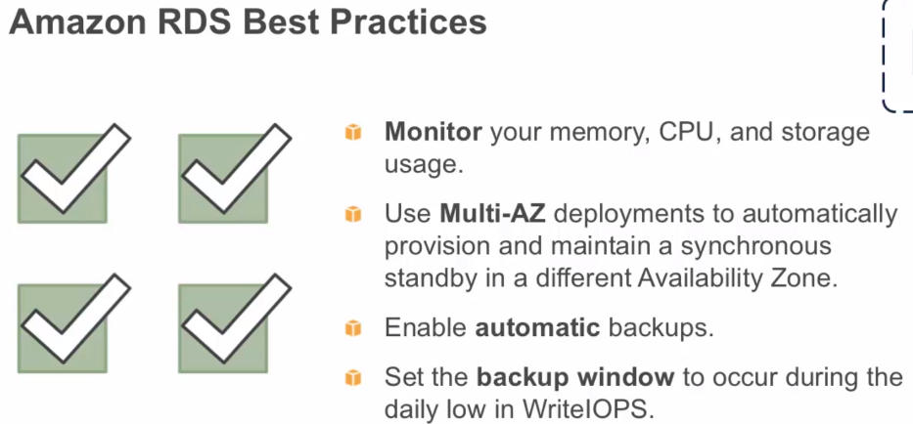

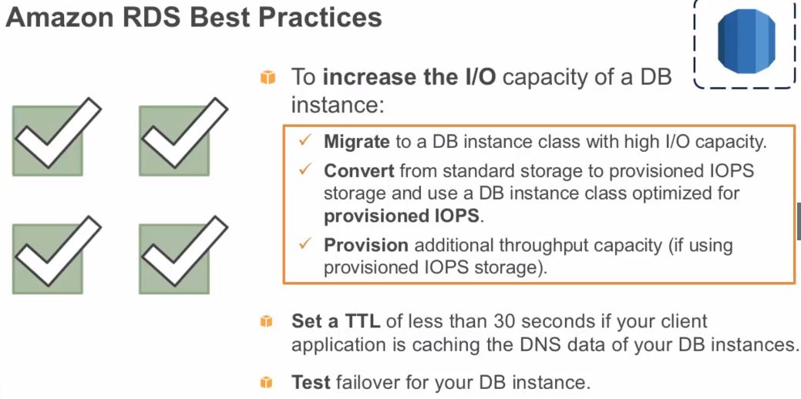

## Section 5, Lecture 49 Amazon DynamoDB

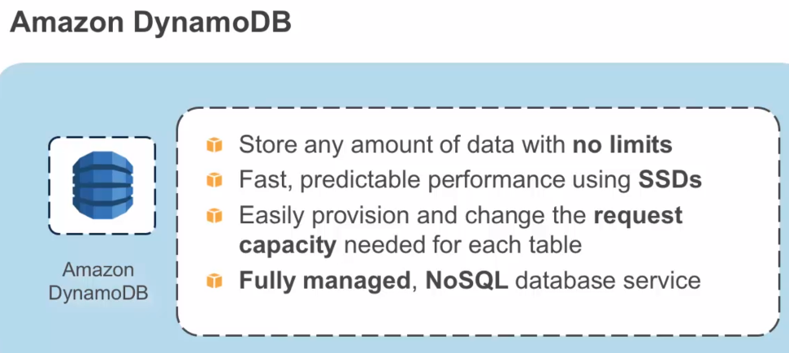

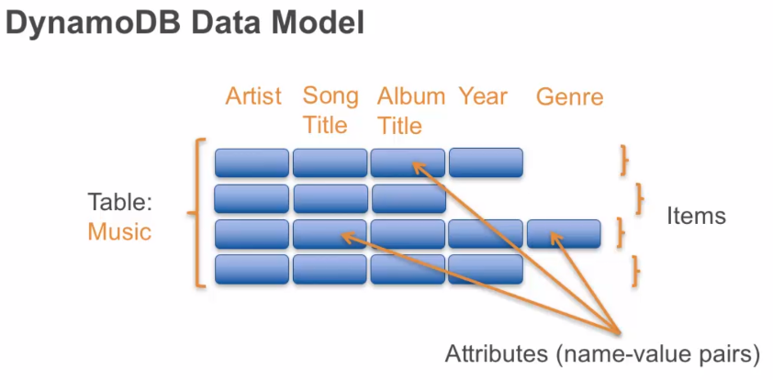

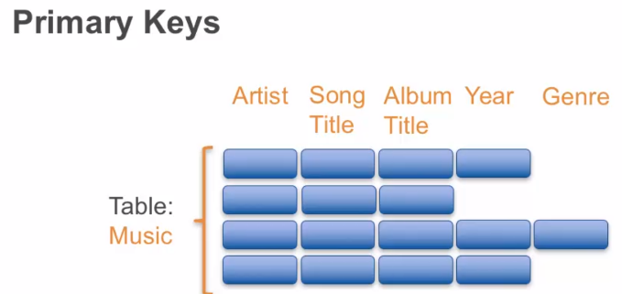

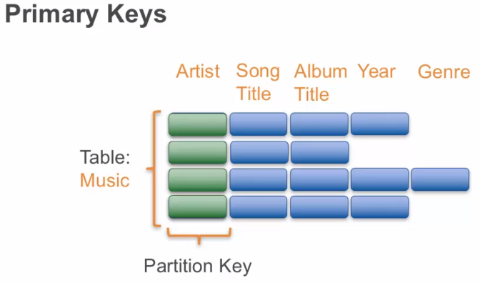

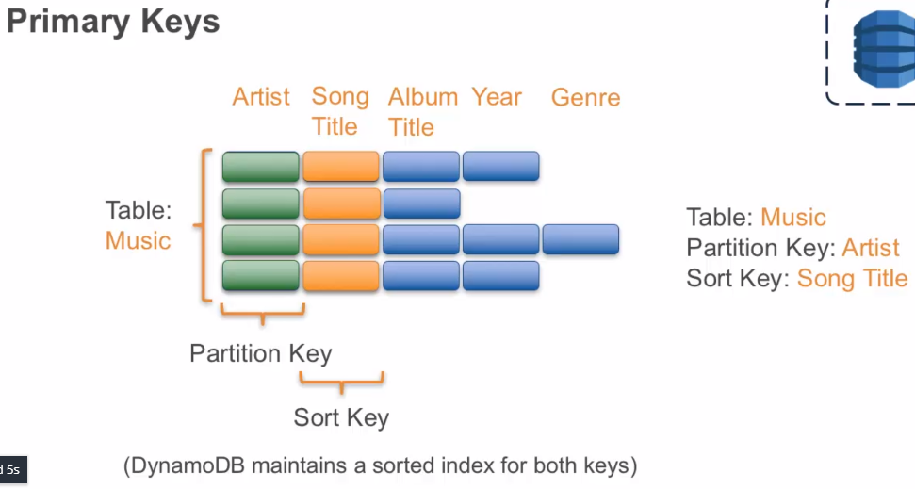

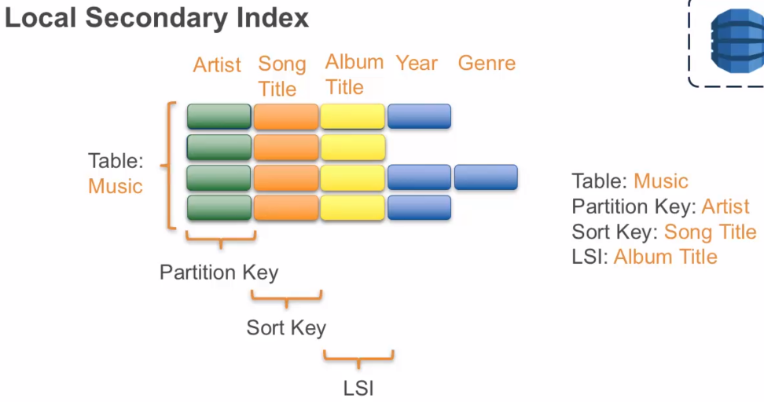

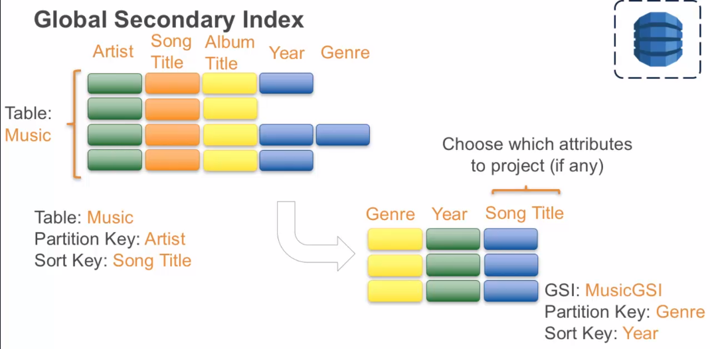

## Section 5, Lecture 50 Supported Operations

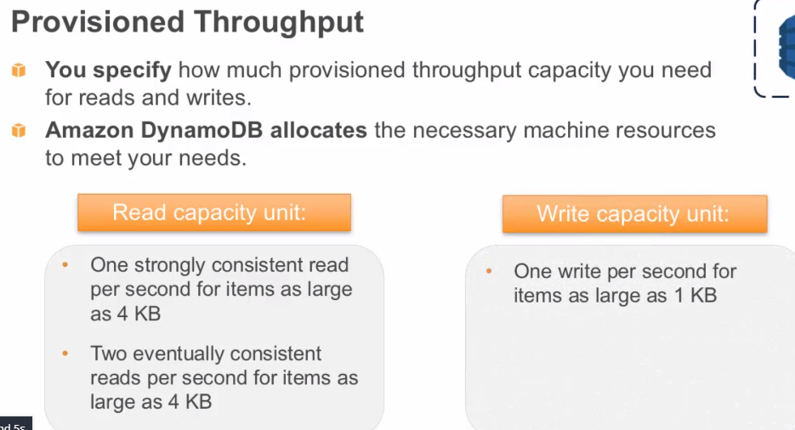

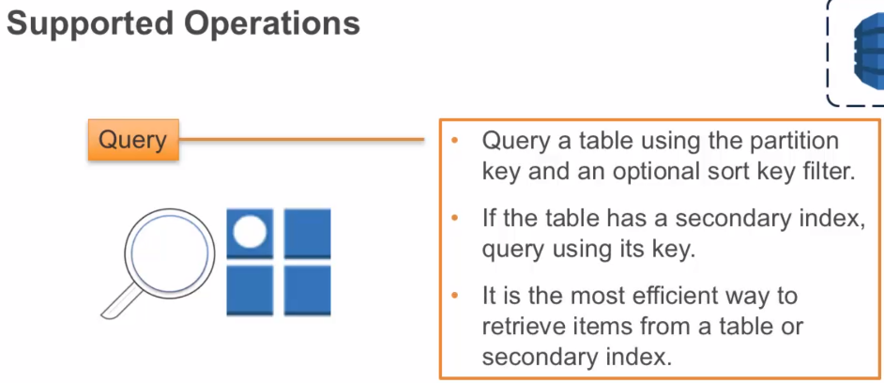

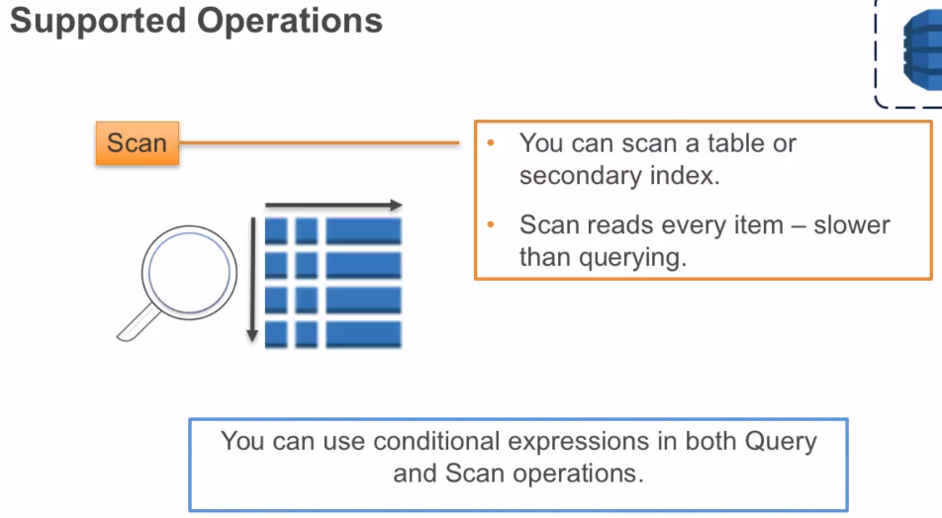

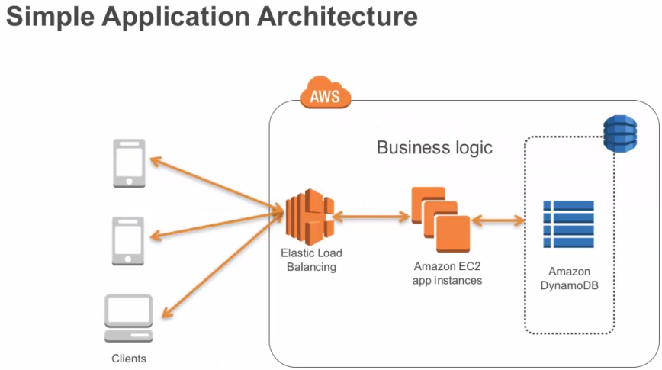

## Section 5, Lecture 51 Amazon RDS and Amazon DynamoDB

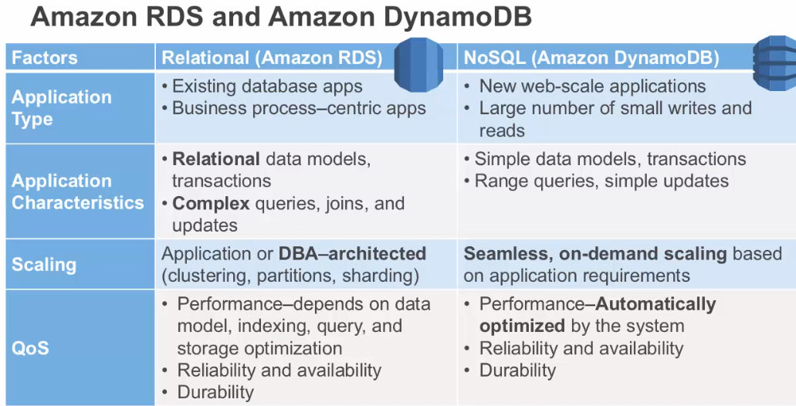

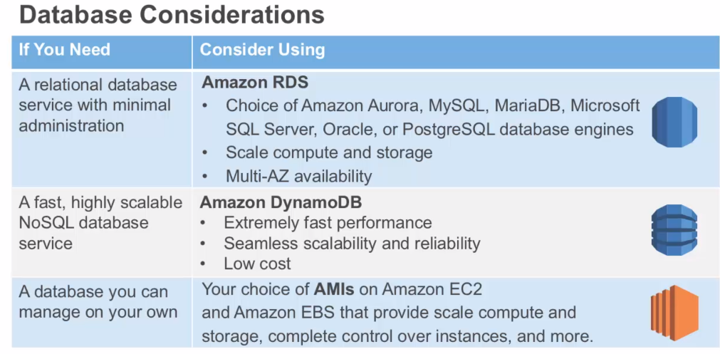

# Section 6 Elasticity and Management Tools

## Section 6, Lecture 54 Elasticity and Management Tools

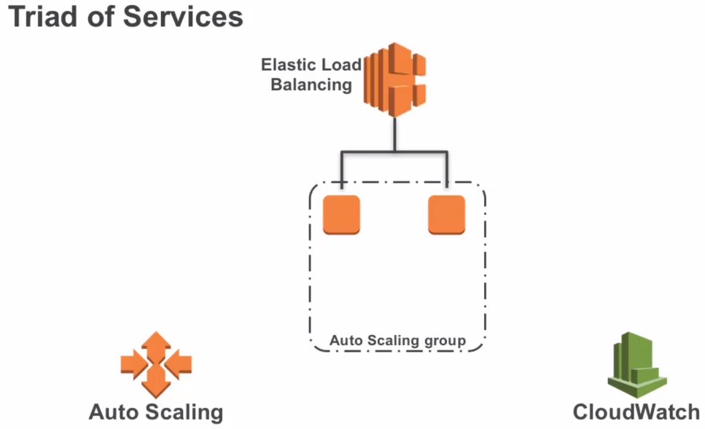

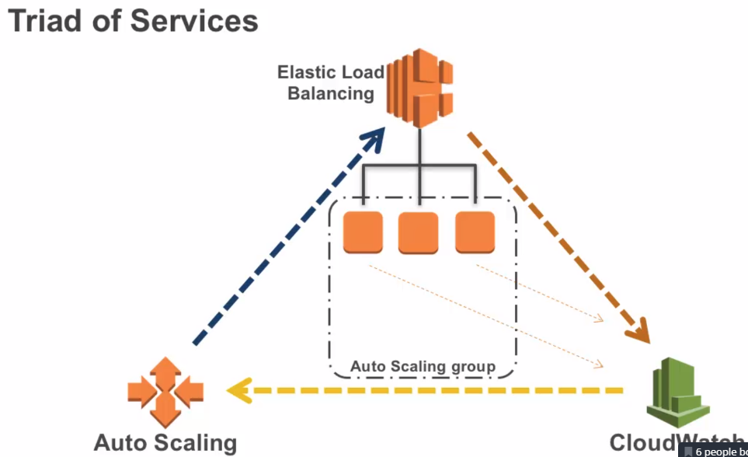

## Section 6, Lecture 55 Auto Scaling

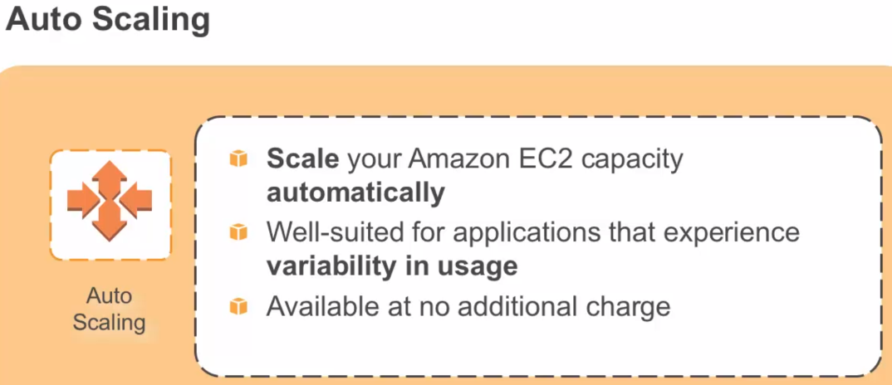

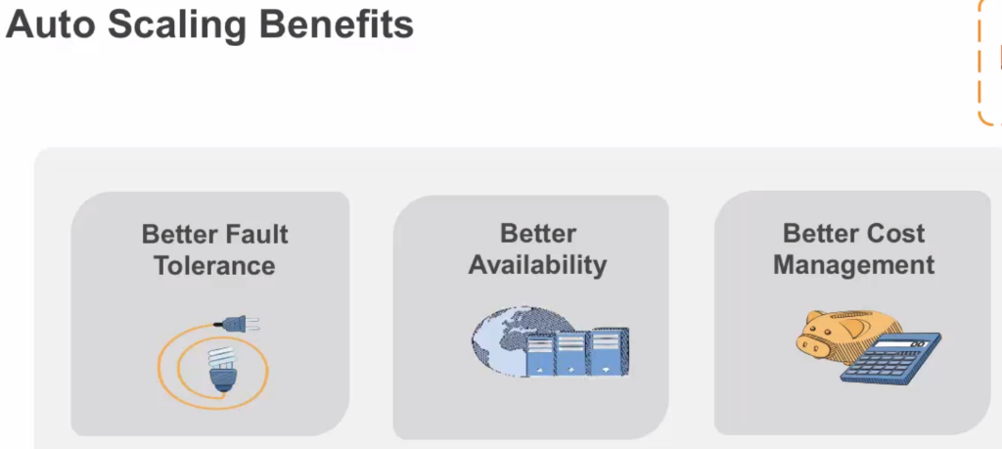

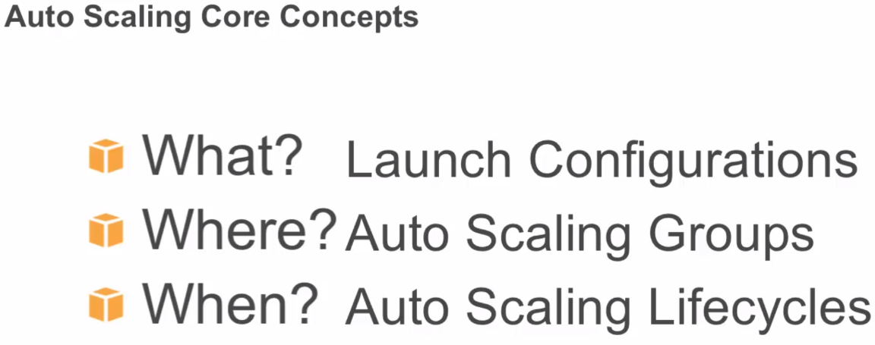

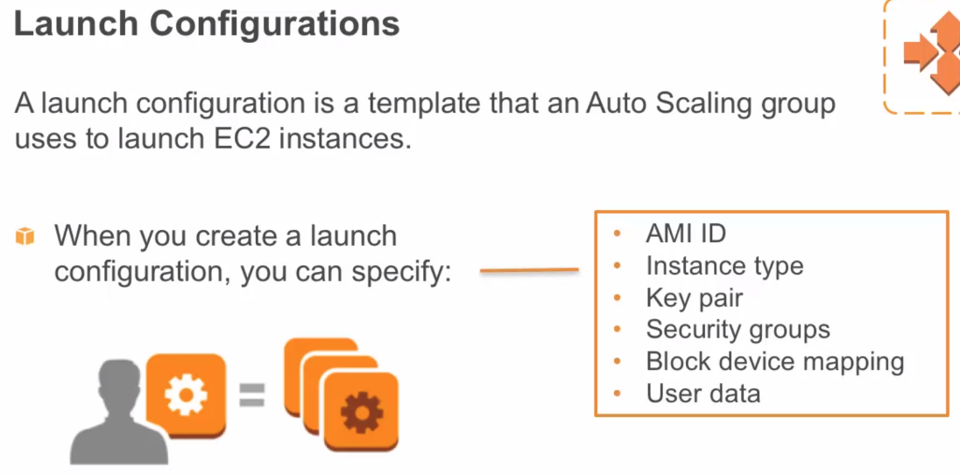

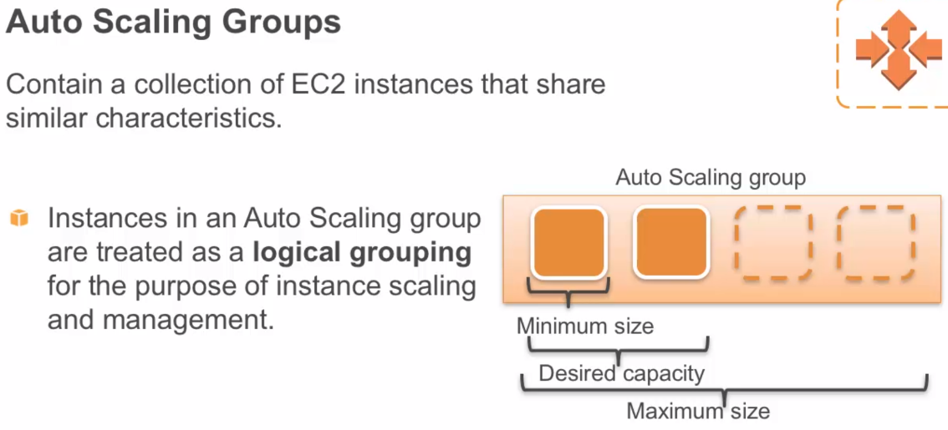

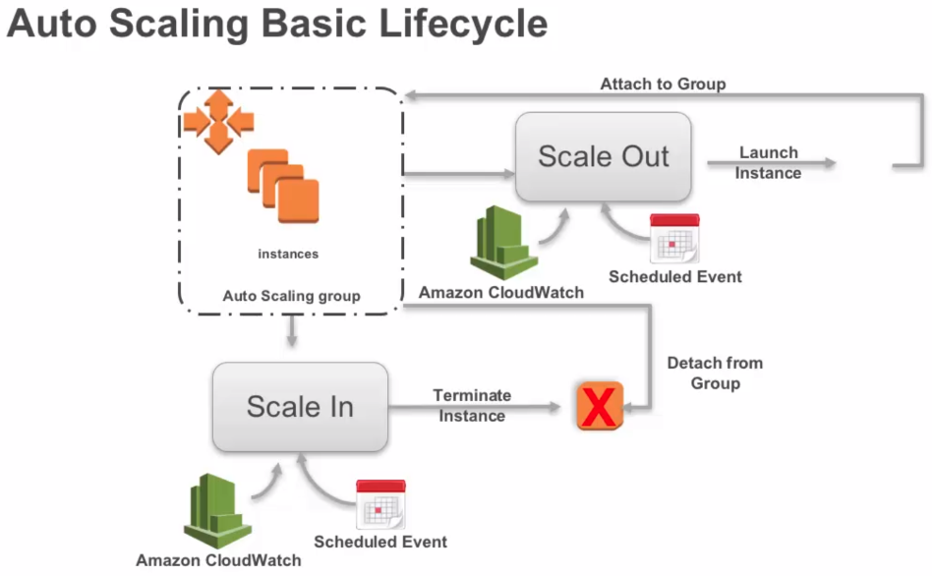

## Section 6, Lecture 56 Elastic Load Balancing

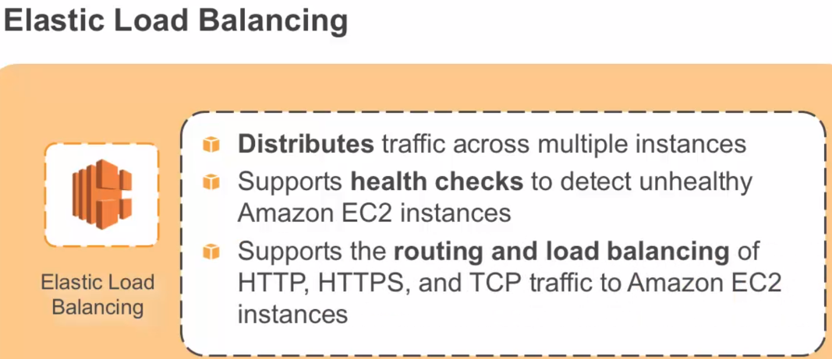

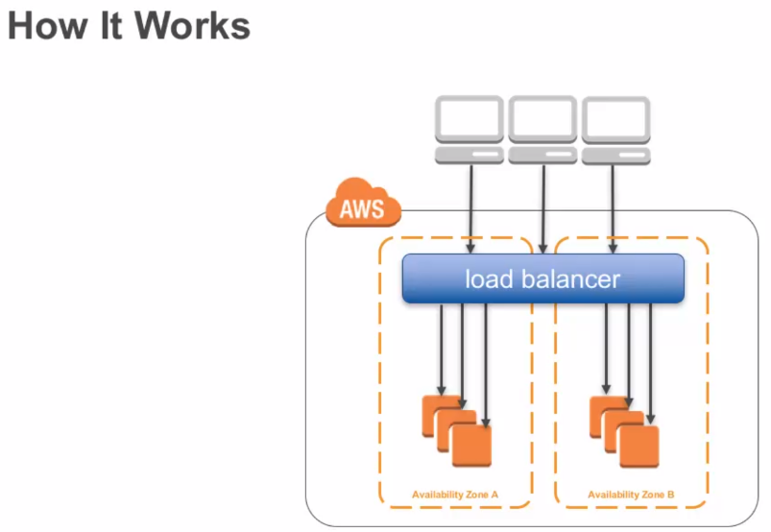

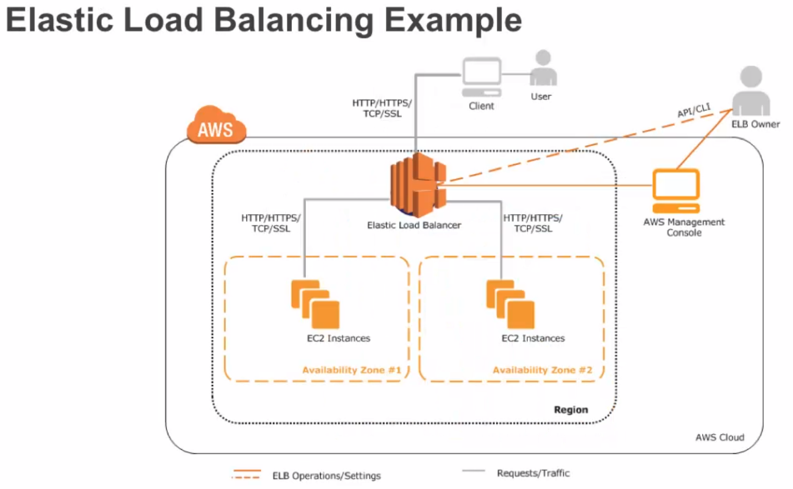

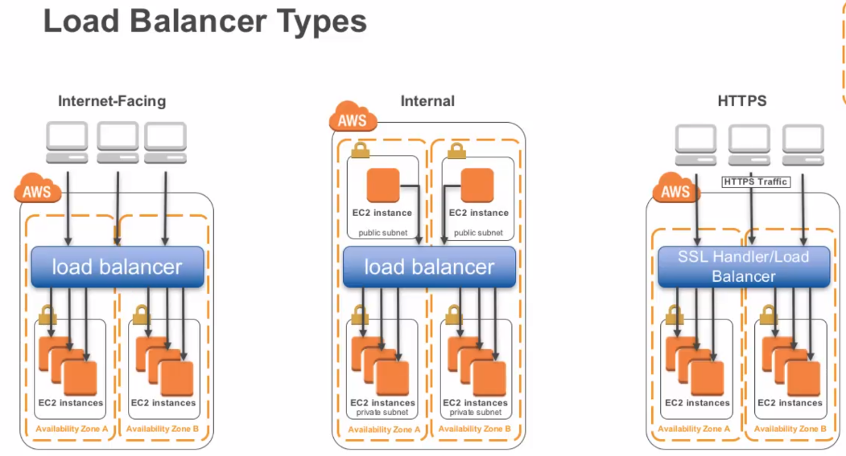

## Section 6, Lecture 57 Amazon CloudWatch

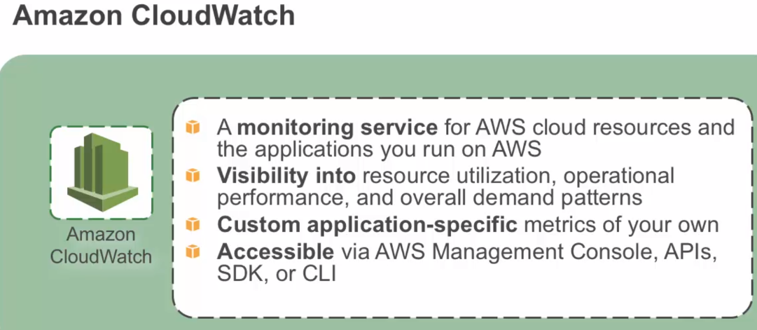

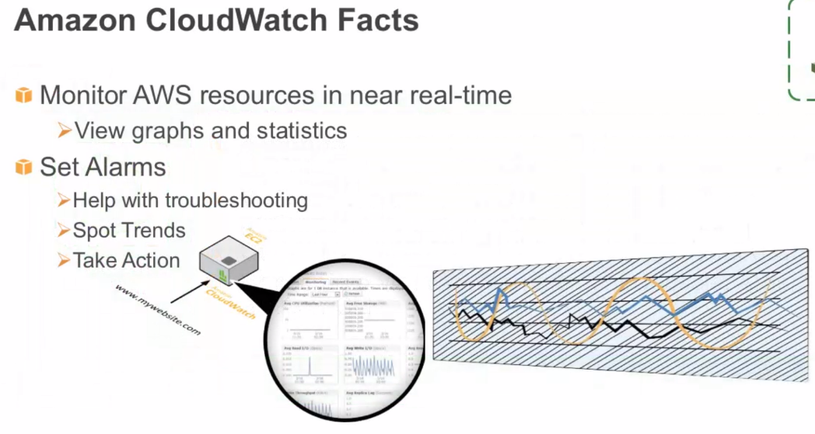

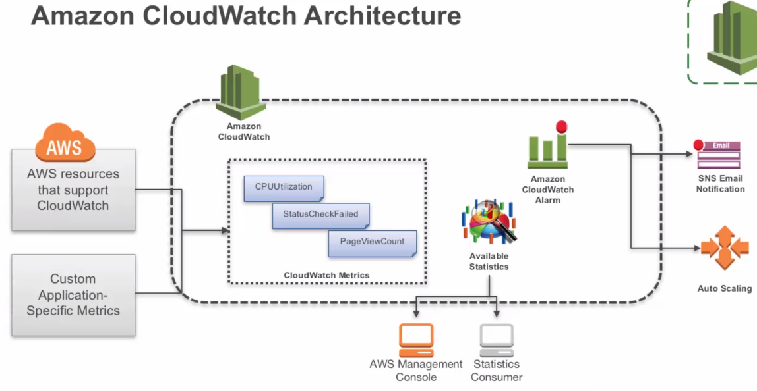

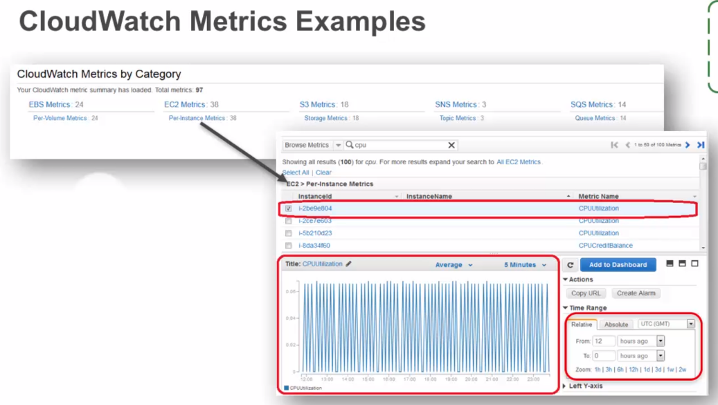

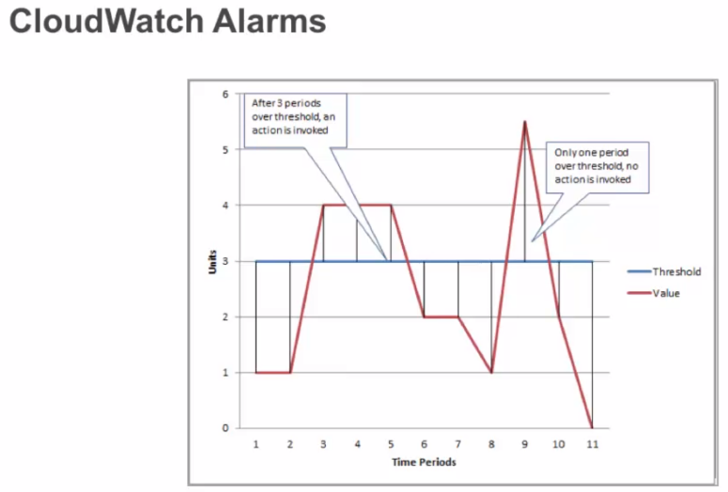

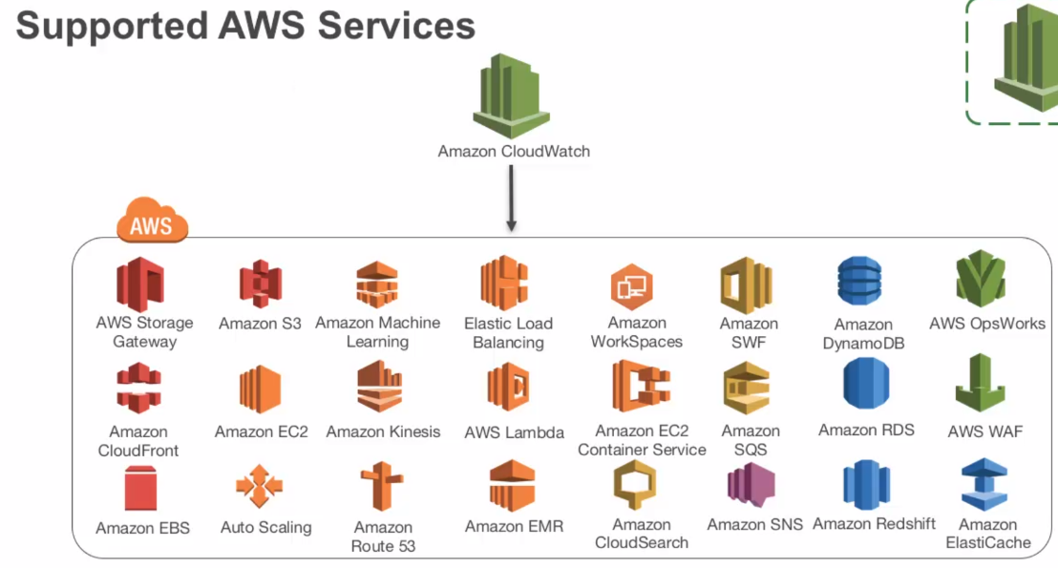

## Section 6, Lecture 58 Trusted Advisor Part 1

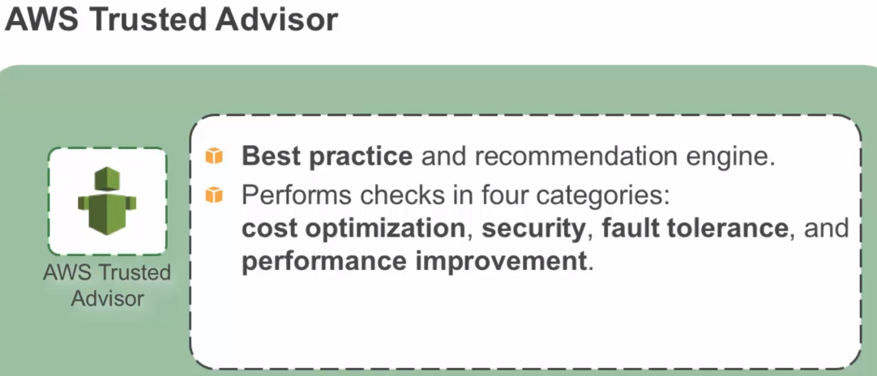

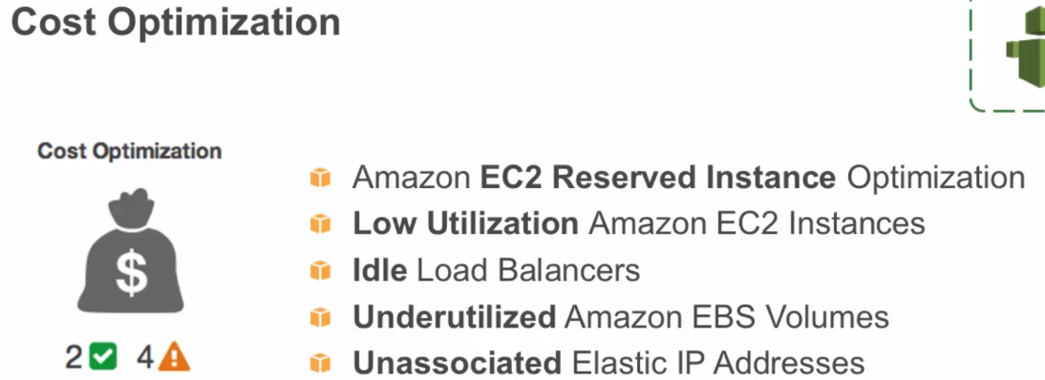

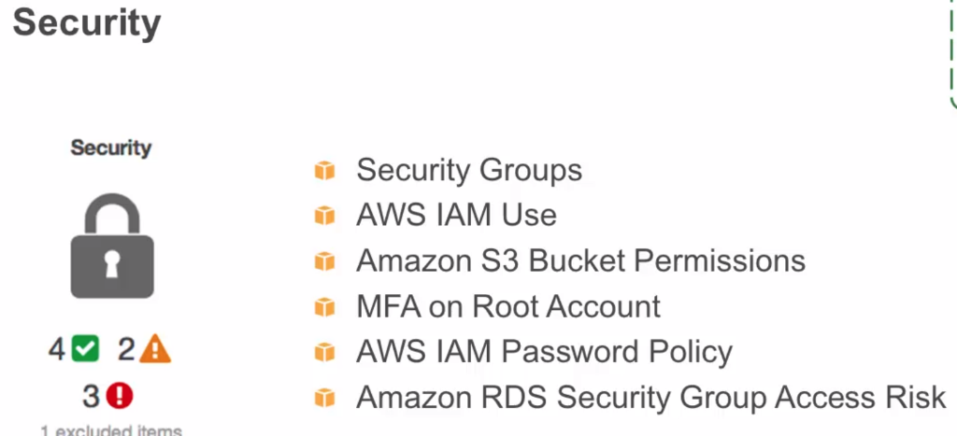

## Section 6, Lecture 59 Trusted Advisor Part 2

## 

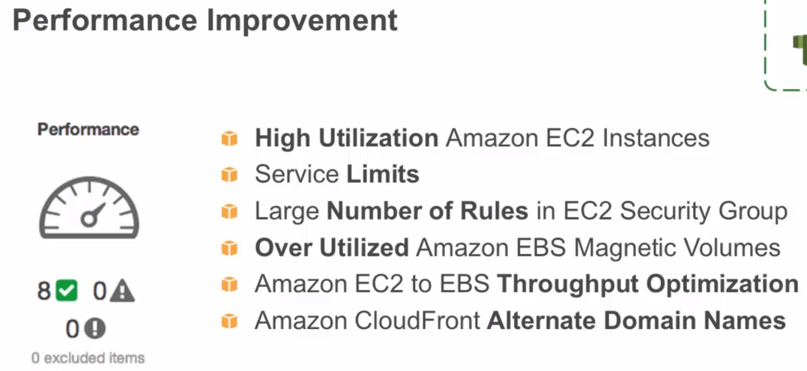

BeanStalk – Java WebApp on Amazon WS

OpenShift Origin - Containerization